**Complete Project Guide Step by Step:**

**Installation of Jenkins**

sudo rpm --import <https://pkg.jenkins.io/redhat-stable/jenkins.io-2023.key>



#yum install fontconfig java*

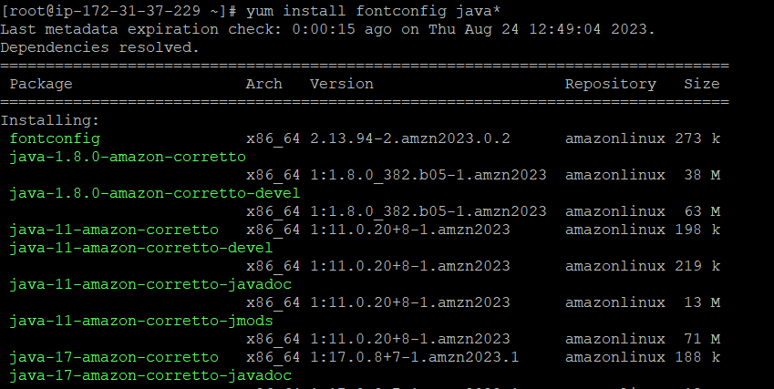

ls -l /usr/lib/jvm/java-1.8.0*

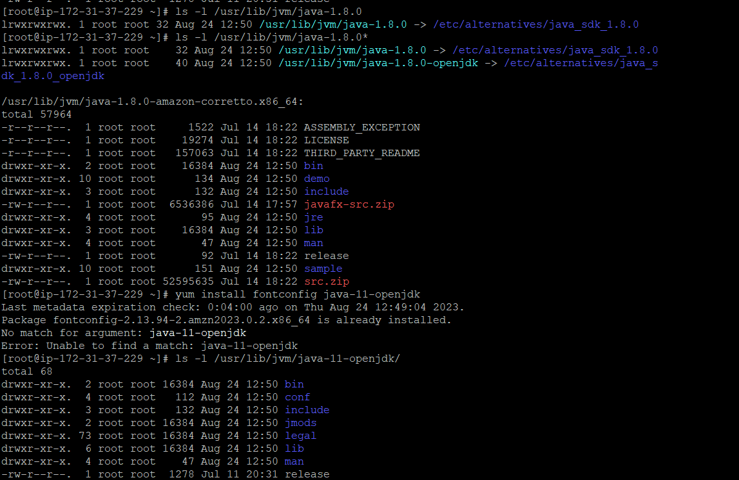

#yum install Jenkins -y

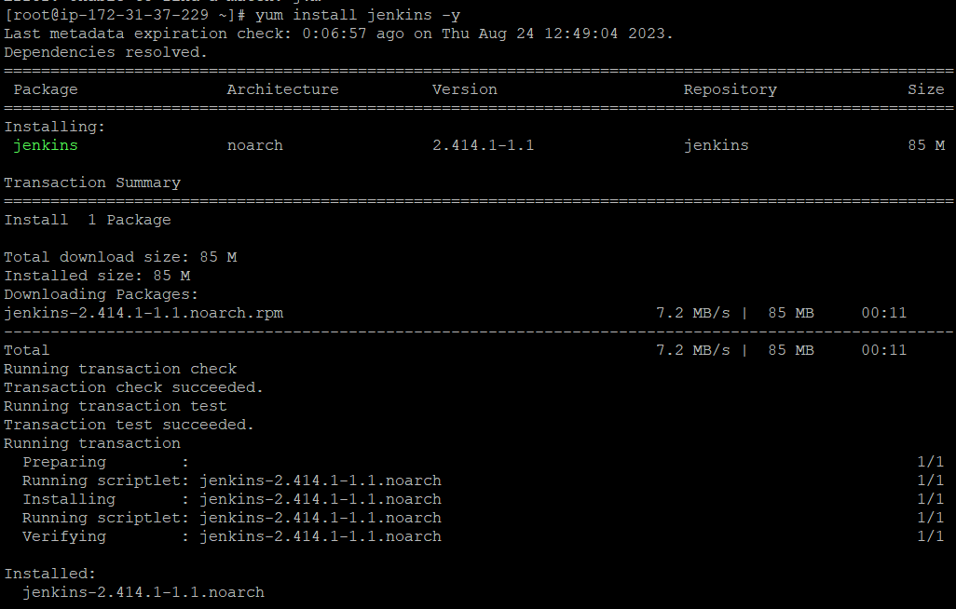

#service jenkins start

#java -version

#service jenkins status

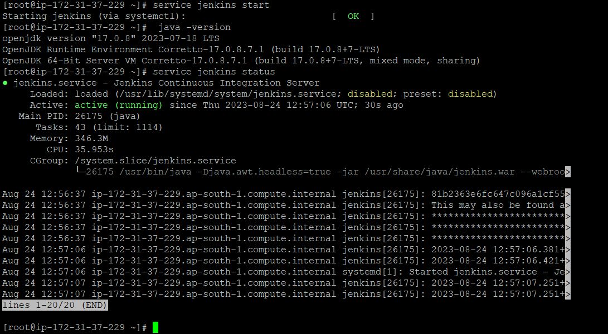

Check inbound rule for security group 8080 port must be added first for browsing jenkins

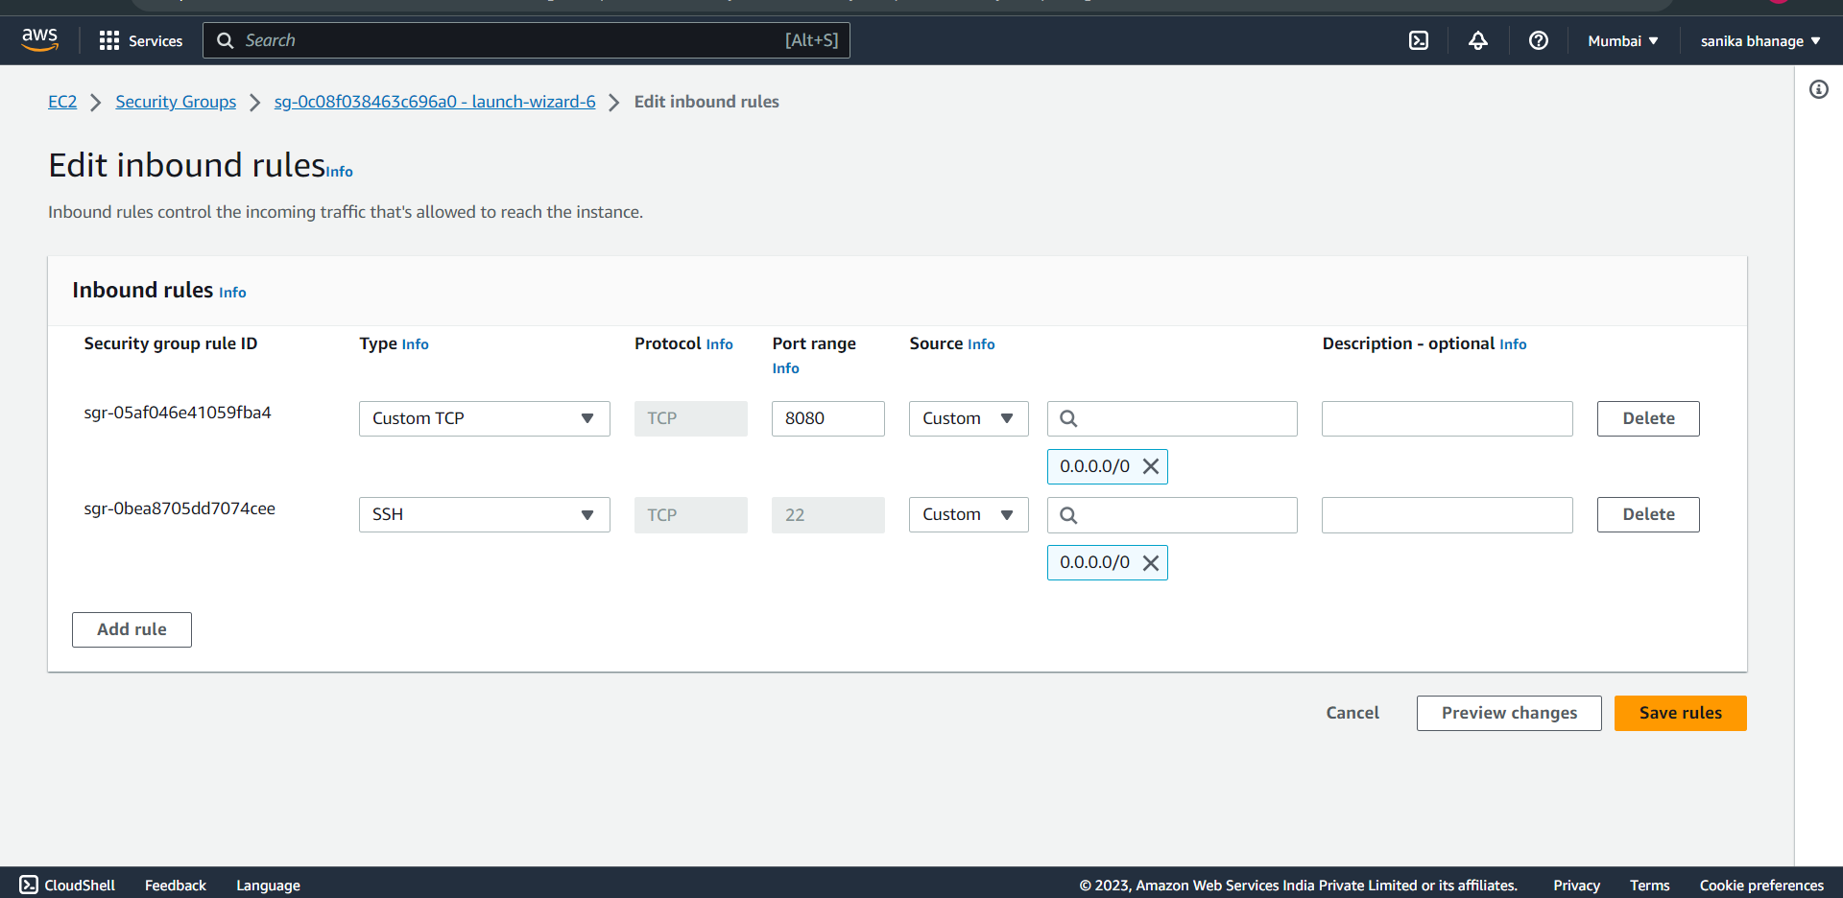

On browser, search for http://publicipv4:8080

#cat /var/lib/jenkins/secrets/initialAdminPassword

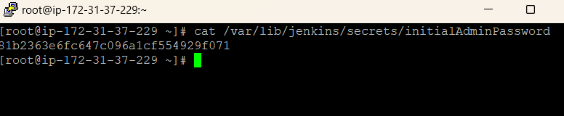

Copy this password and paste it in browser,

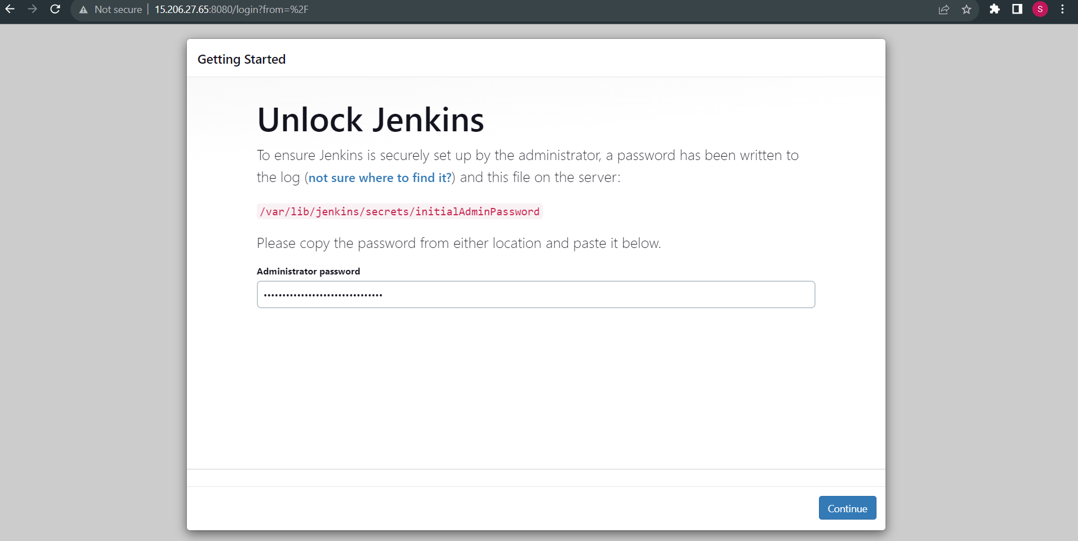

Not installation of any plugin just start jenkins,

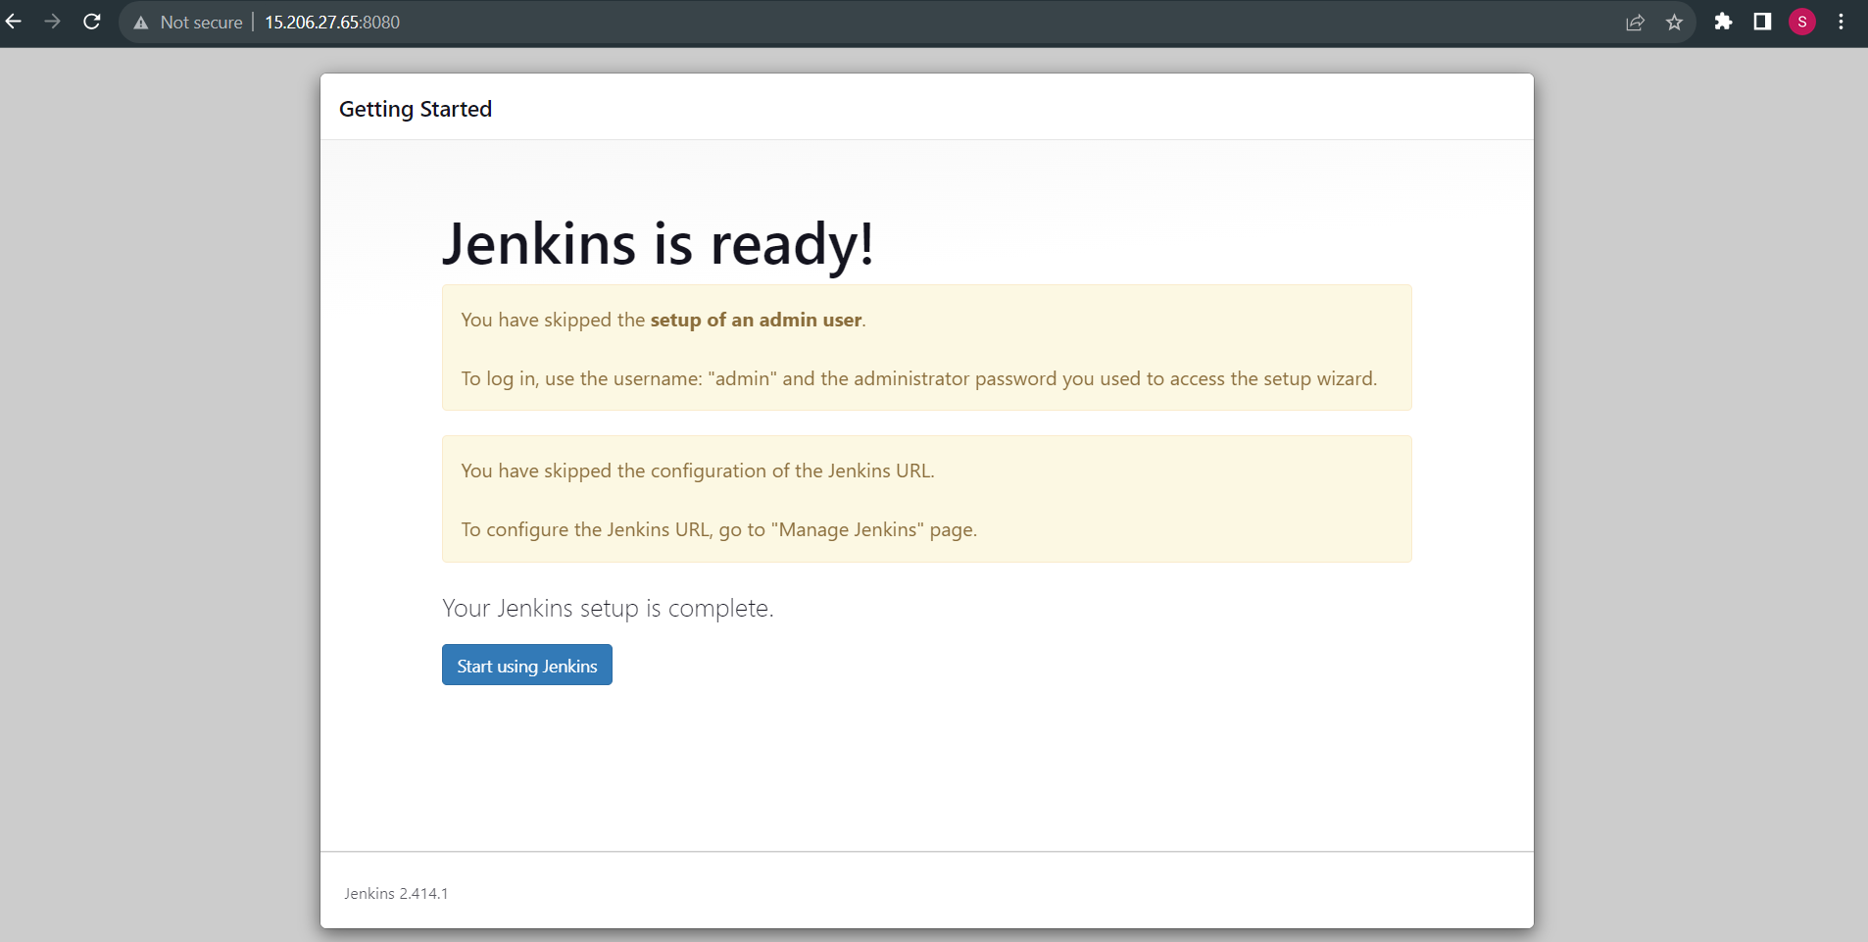

Jenkins dashboard,

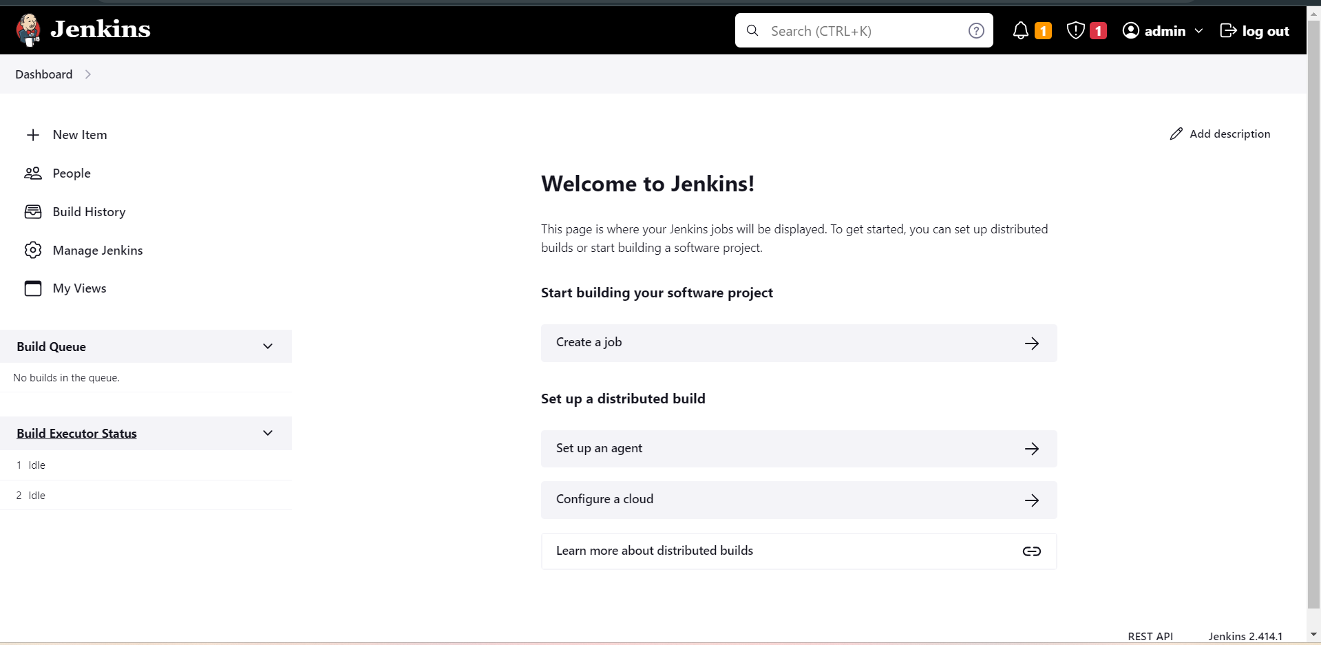

Change the jenkins default password, dashboard -> admin->configure

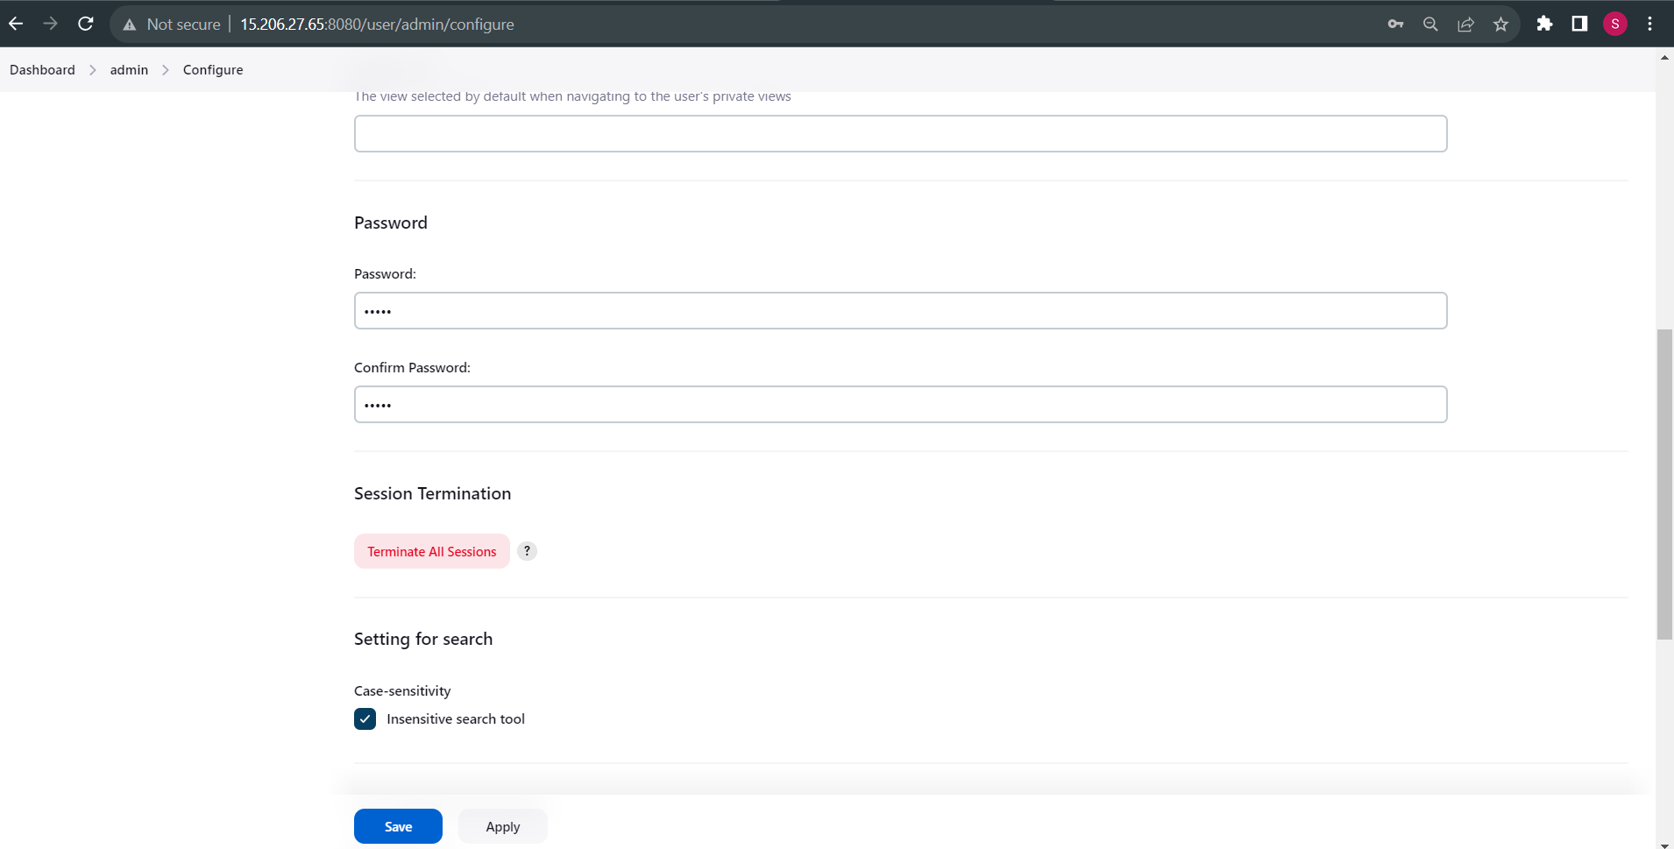

Again login with new password,

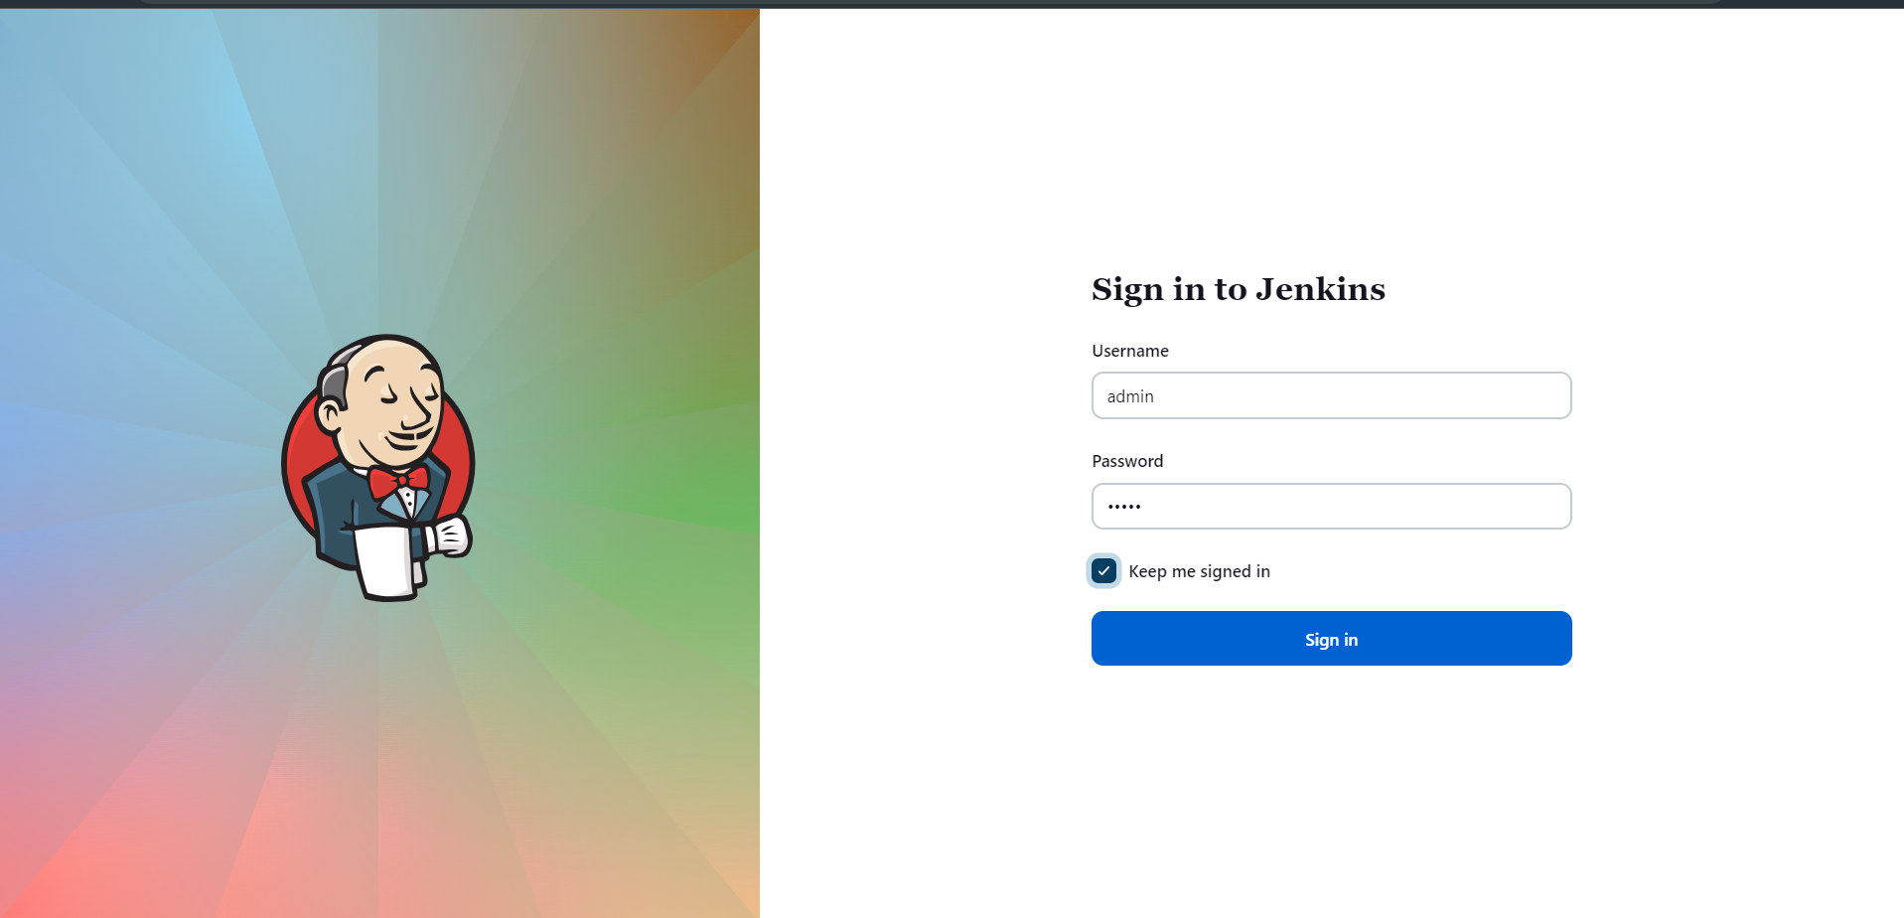

Set JAVA HOME PATH

#ls -l /usr/lib/jvm/

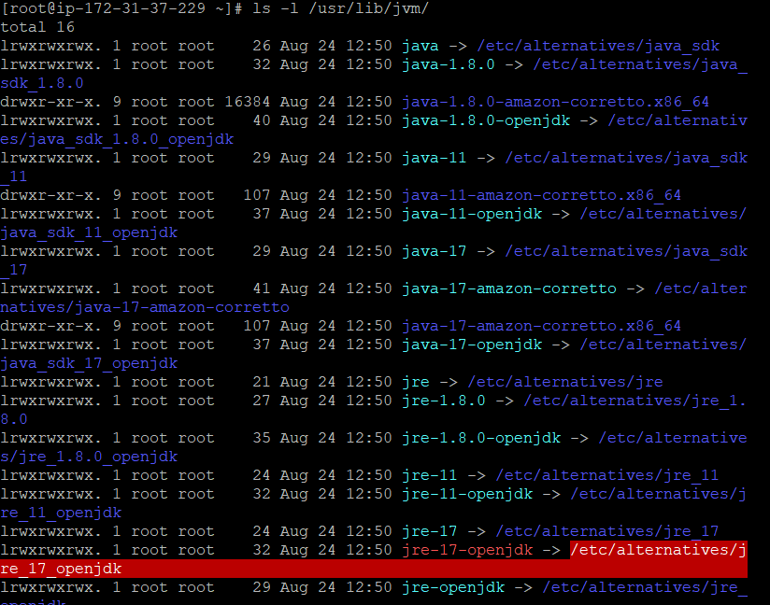

#ls -l /usr/lib/jvm/java-17-amazon-corretto.x86_64/

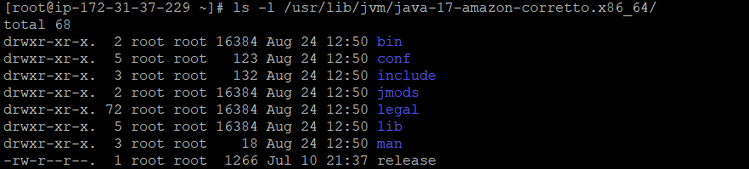

#vi ~/.bash_profile paste the path add JAVA_HOME

# sourch ~/.bash_profile

#java -version

#echo $JAVA_HOME

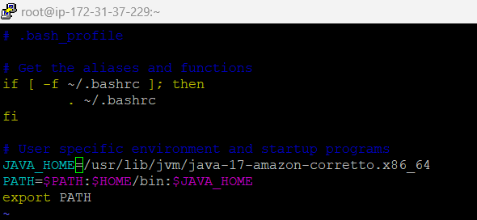

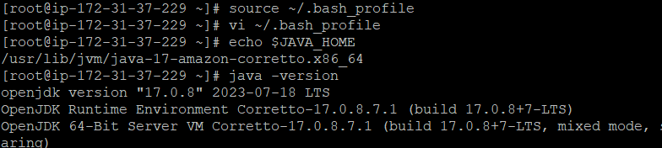

Now, we have to set java home path for that go to Manage jenkins->Tools-> Add JDK click apply & save.

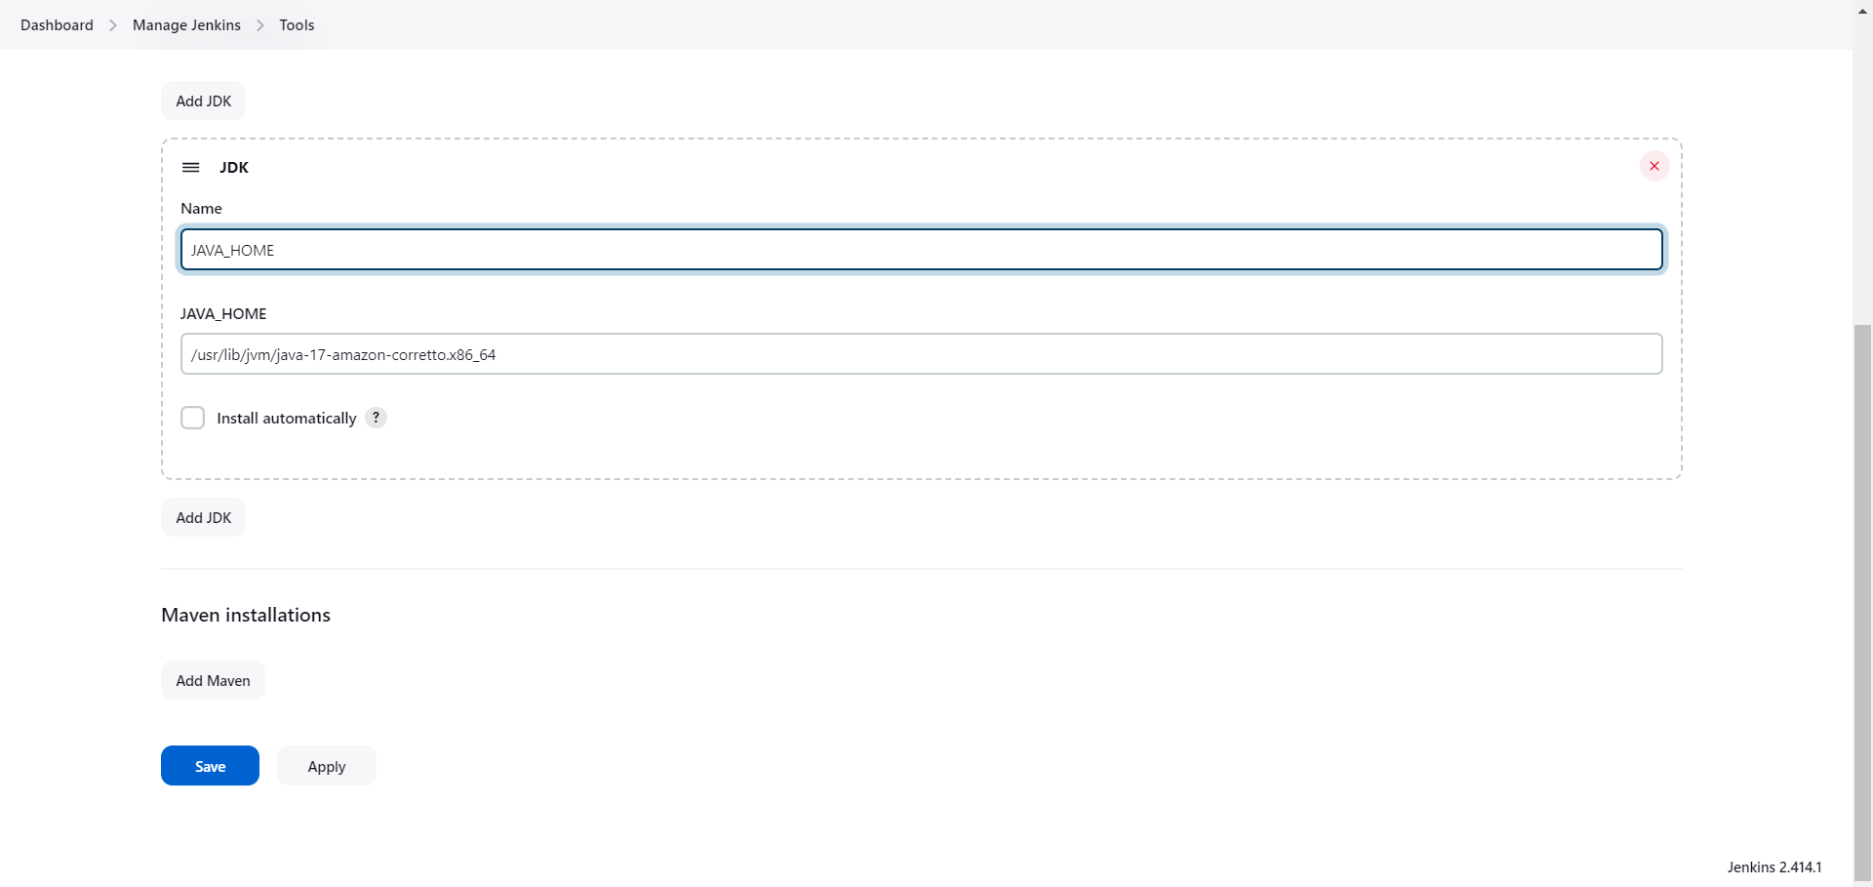

Run the first jenkins job,

Dashboard -> new item -> add item name -> click free style project -> ok

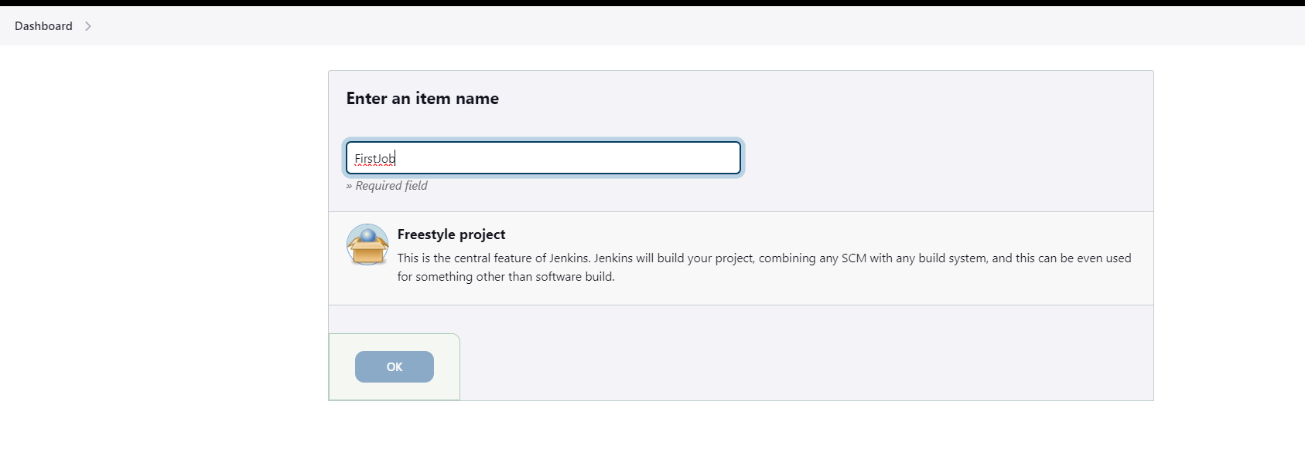

Give description

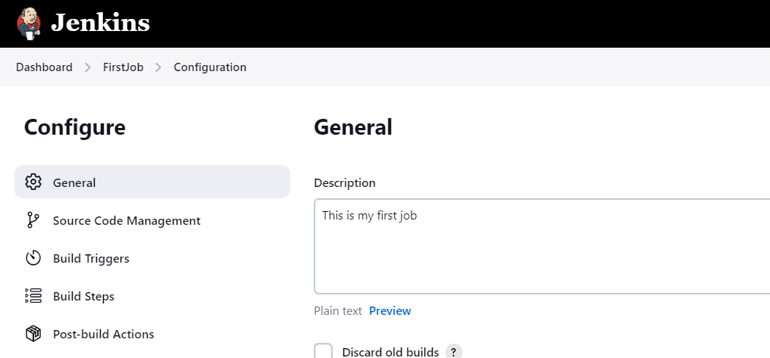

Select source code management -> none

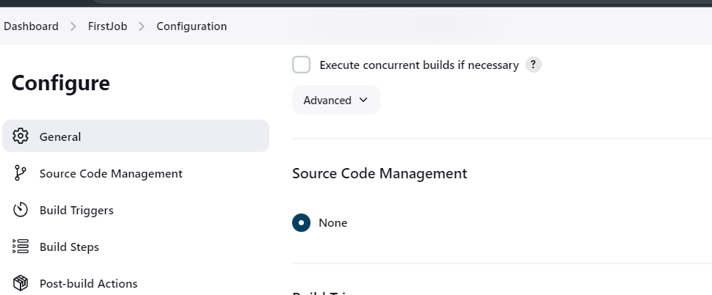

Select Execute Shell and click on apply and save.

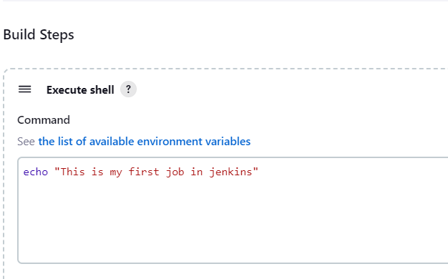

Click on Build Now and see the first job status

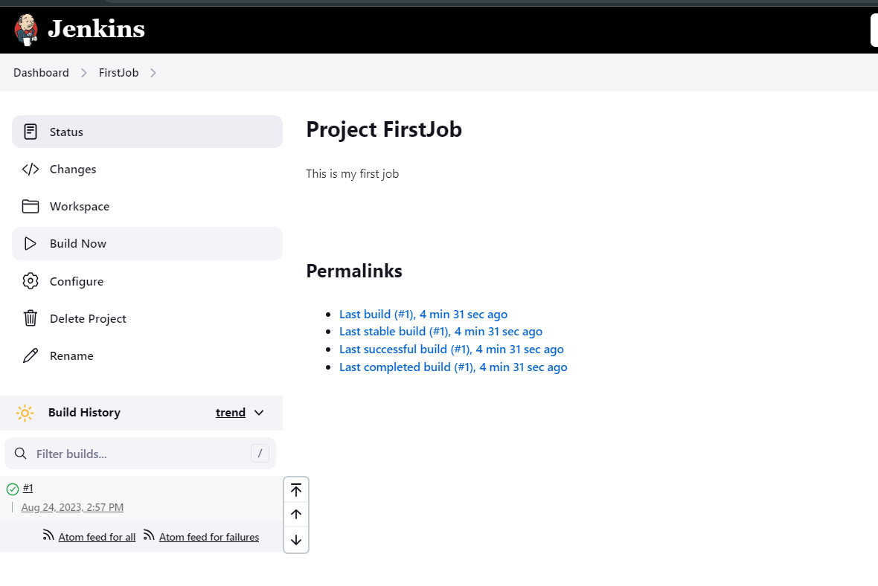

**Setup Git**

#yum install git -y

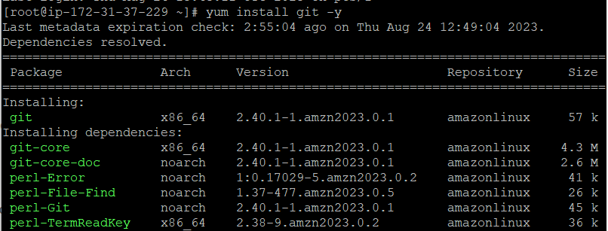

Manage Jenkins > Jenkins Plugins > available > github click on install

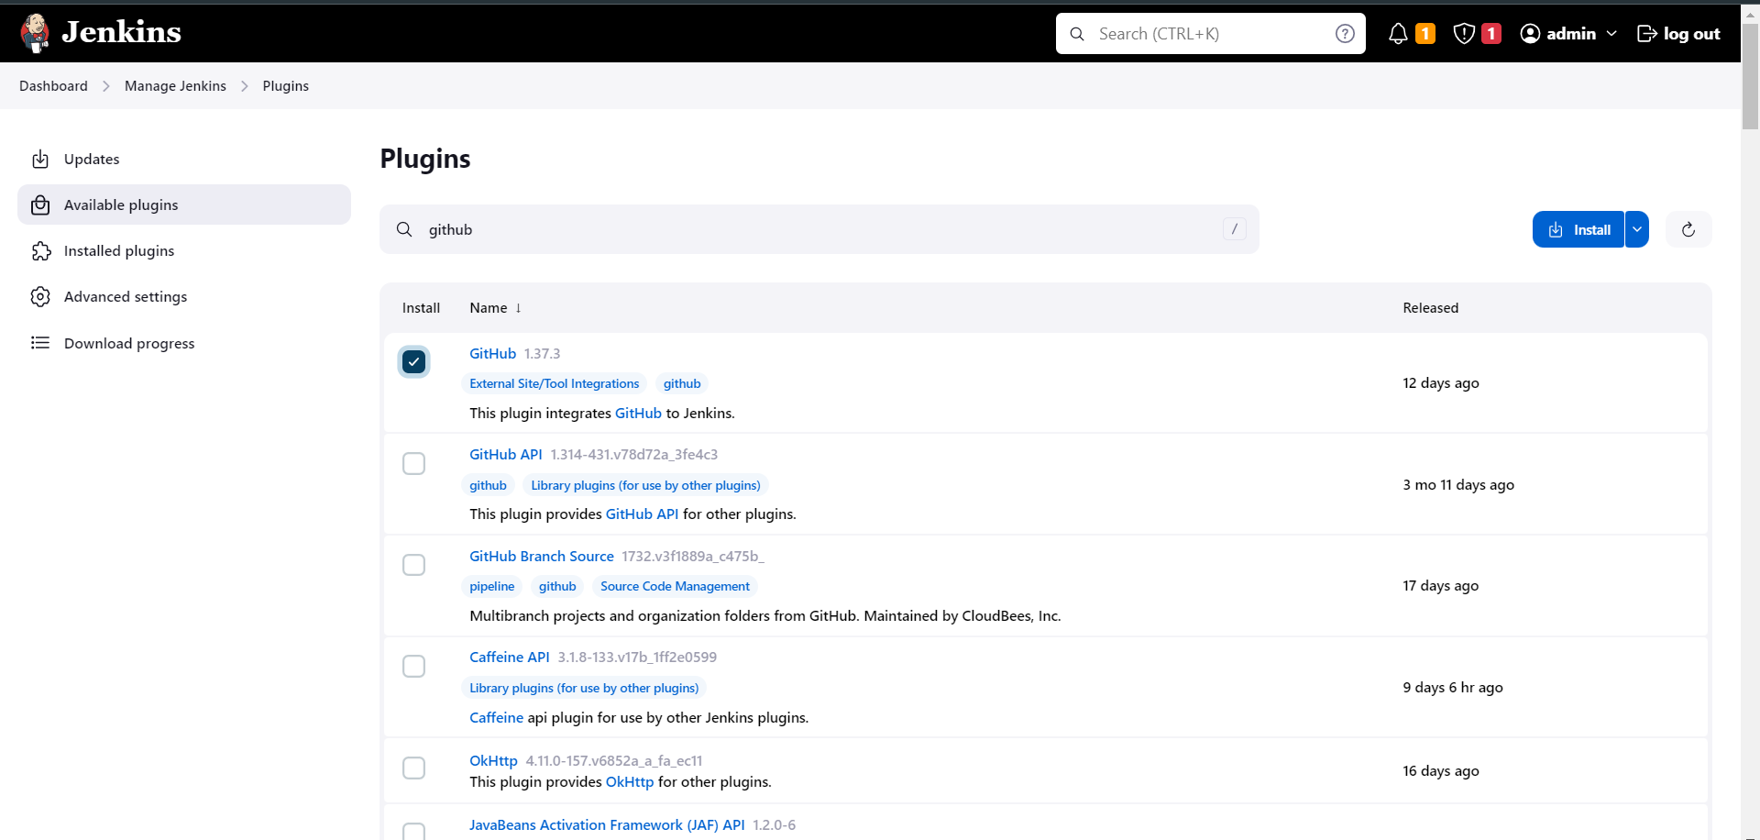

After the successful installation go to the Dashboard -> Manage jenkins -> Tools

Add git path and click on apply and save.

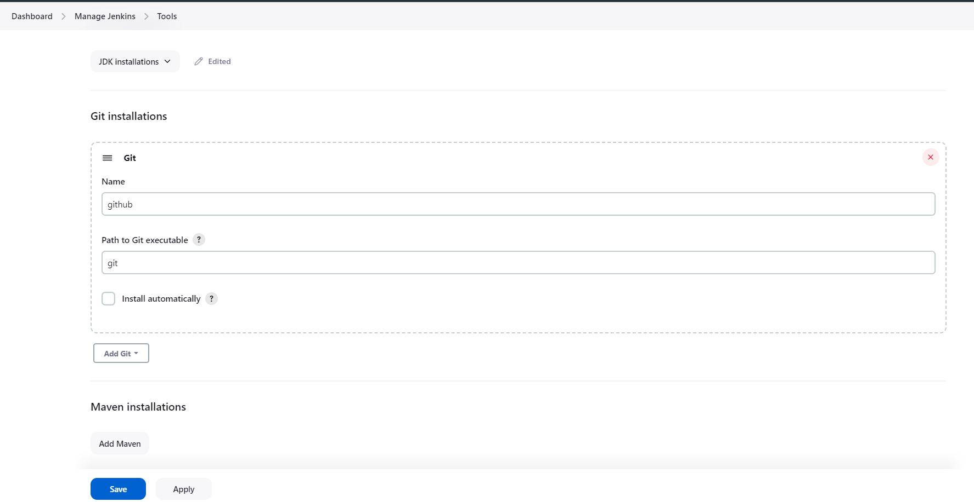

**Setup Maven**

cd /opt

ls -ltr

wget https://dlcdn.apache.org/maven/maven-3/3.8.8/binaries/apache-maven-3.8.8-bin.tar.gz

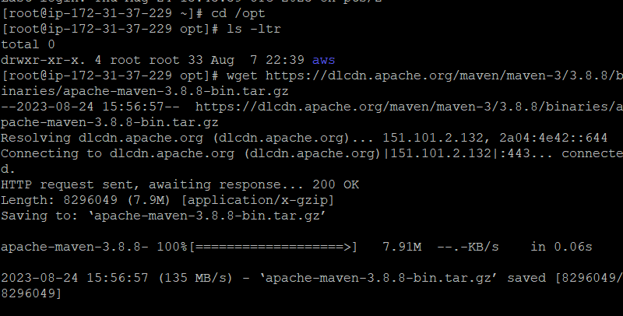

tar -xvzf apache-maven-3.8.8-bin.tar.gz

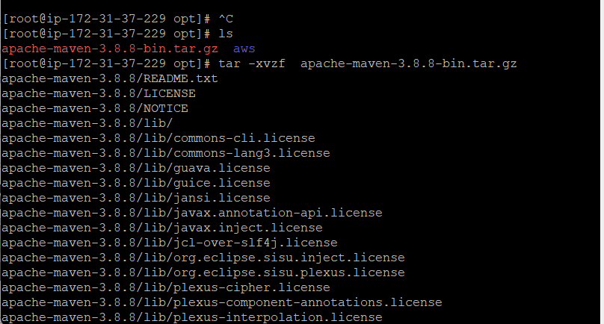

mv apache-maven-3.8.8 maven

cd maven/

pwd

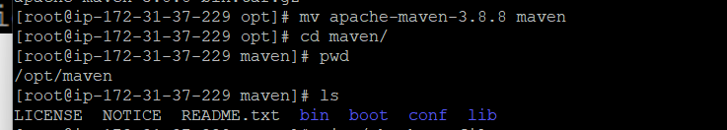

vi ~/.bash_profile

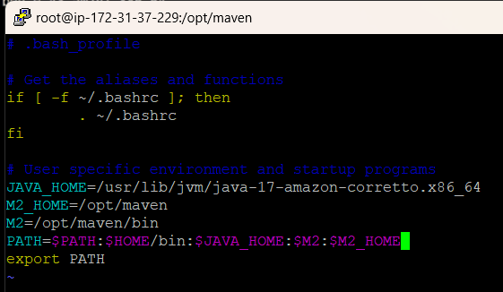

source ~/.bash_profile

mvn -version

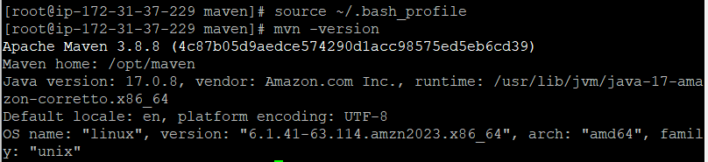

#echo $M2

#echo $M2_HOME

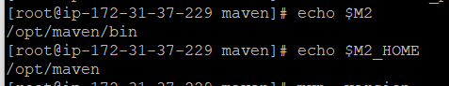

In the Manage jenkins -> plugins -> available plugin search maven and select “Maven Integration” & “Maven Invoker” click Install.

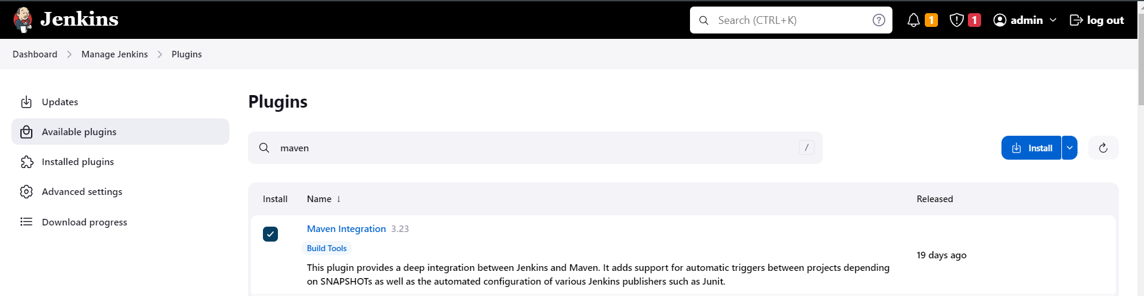

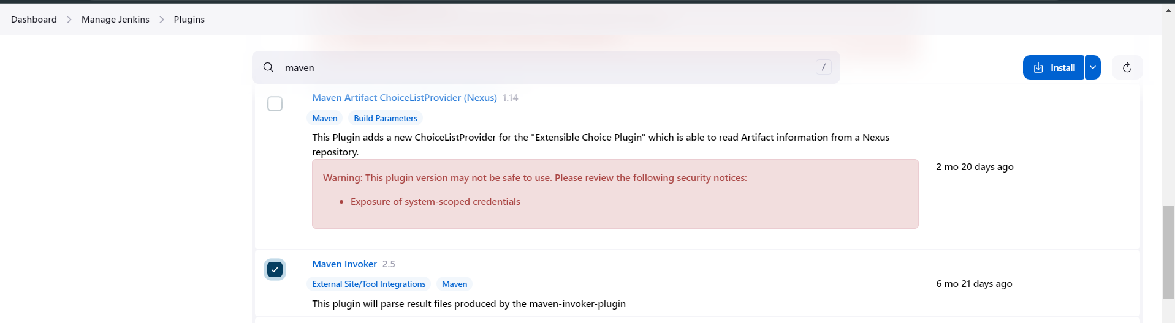

Now set maven path

Manage jenkins-> Tools -> maven -> add path click on apply and save

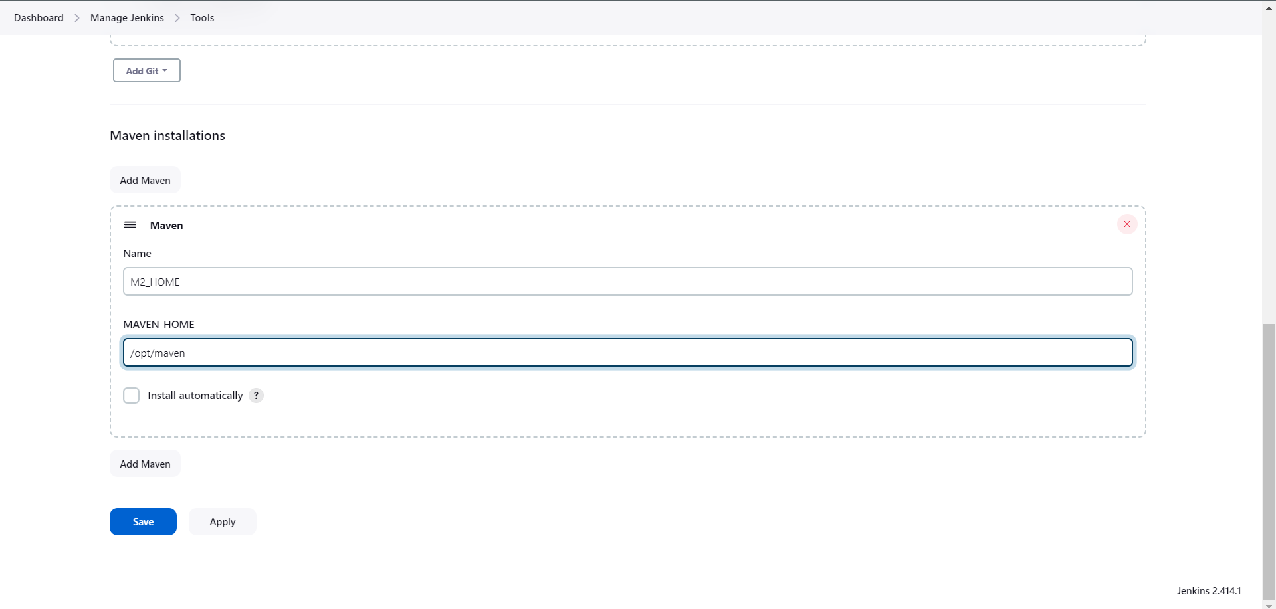

Create first maven job

Dashboard->Add new Item-> give item name -> select maven project->click on ok

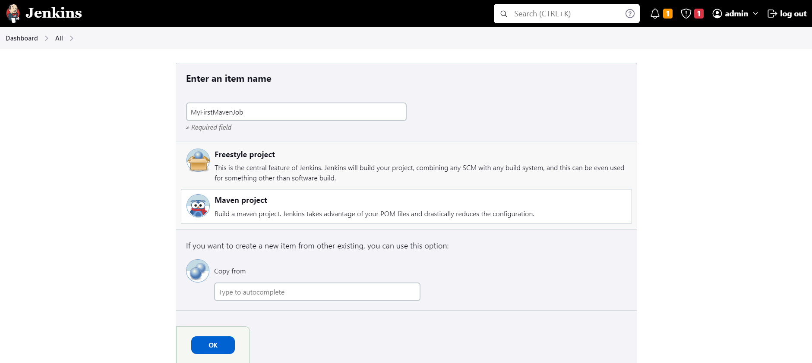

Add general description of job

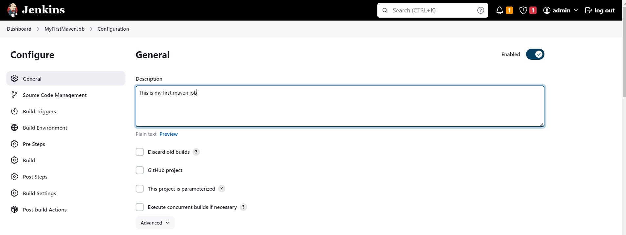

Select source code management -> git -> add git project repo url -> if it is private then only add credentials. If you have to pull from master branch then use “*/master” instead of master you can specify your required branch, from which project will be pull inside jenkins.

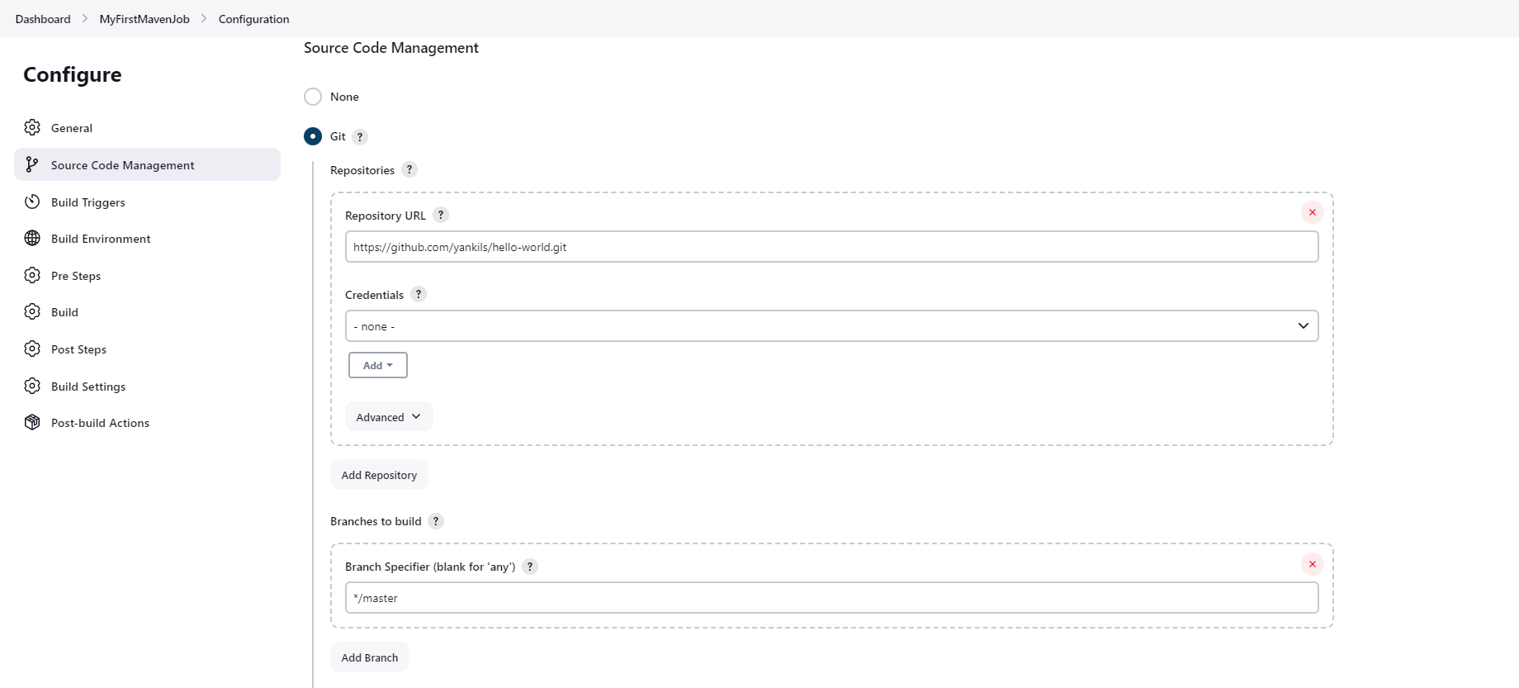

Pom.xml required to build job of maven project. Hence this file essential in your github repo . click on apply and save and click on Build Now

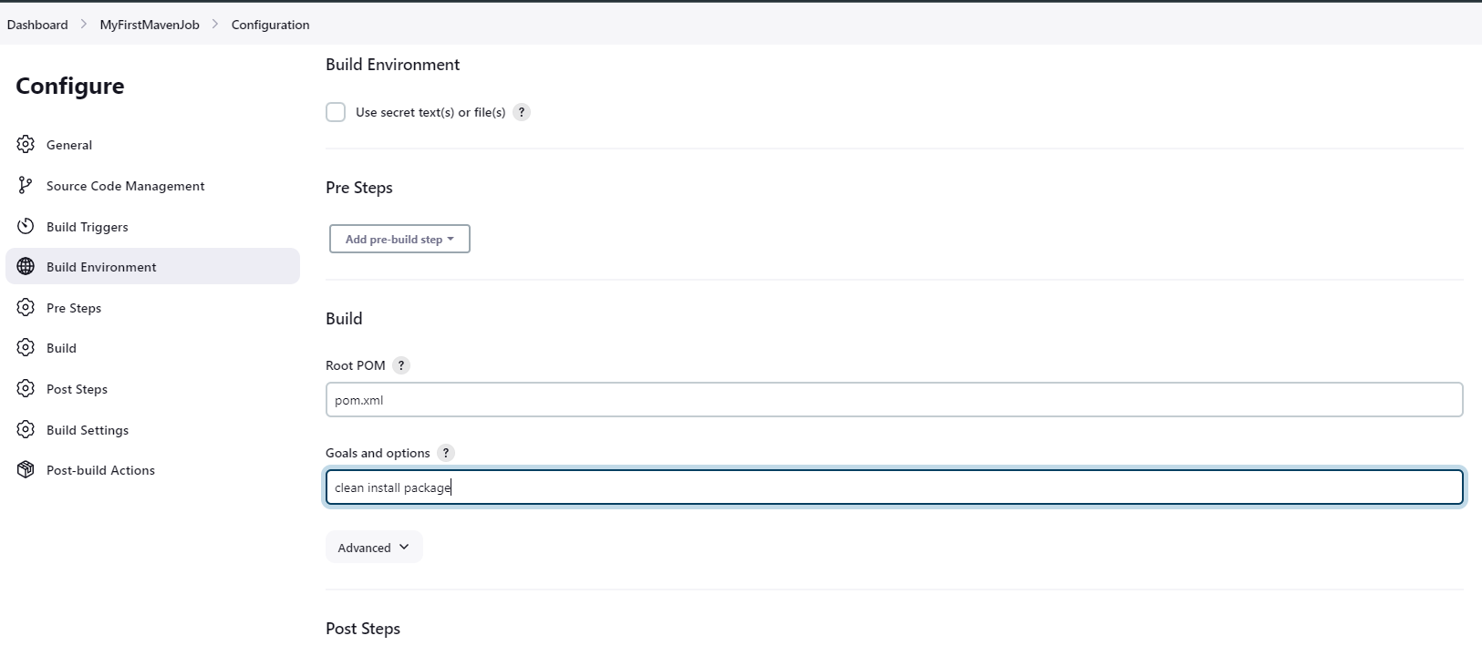

It will change the status to green if job is builded successfully.

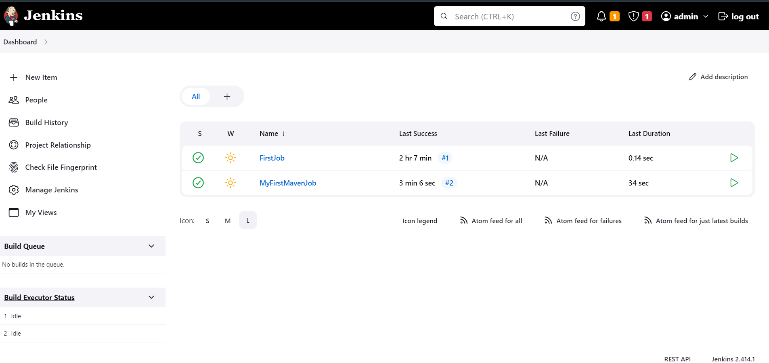

You can see the successfully builded job repos here also with webapp.war file required for maven.

cd /var/lib/jenkins/workspace/

cd MyFirstMavenJob/

ls

cd webapp/

cd target/

ls

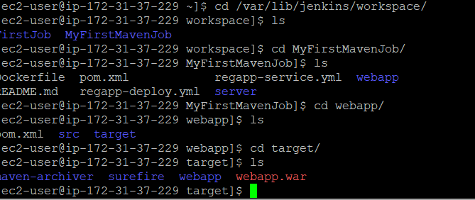

To host this webapp.war we need tomacat server ,

**Setup Tomcat Server**

Add the port 8090 in the security group as tomcat and jenkins both have same port number

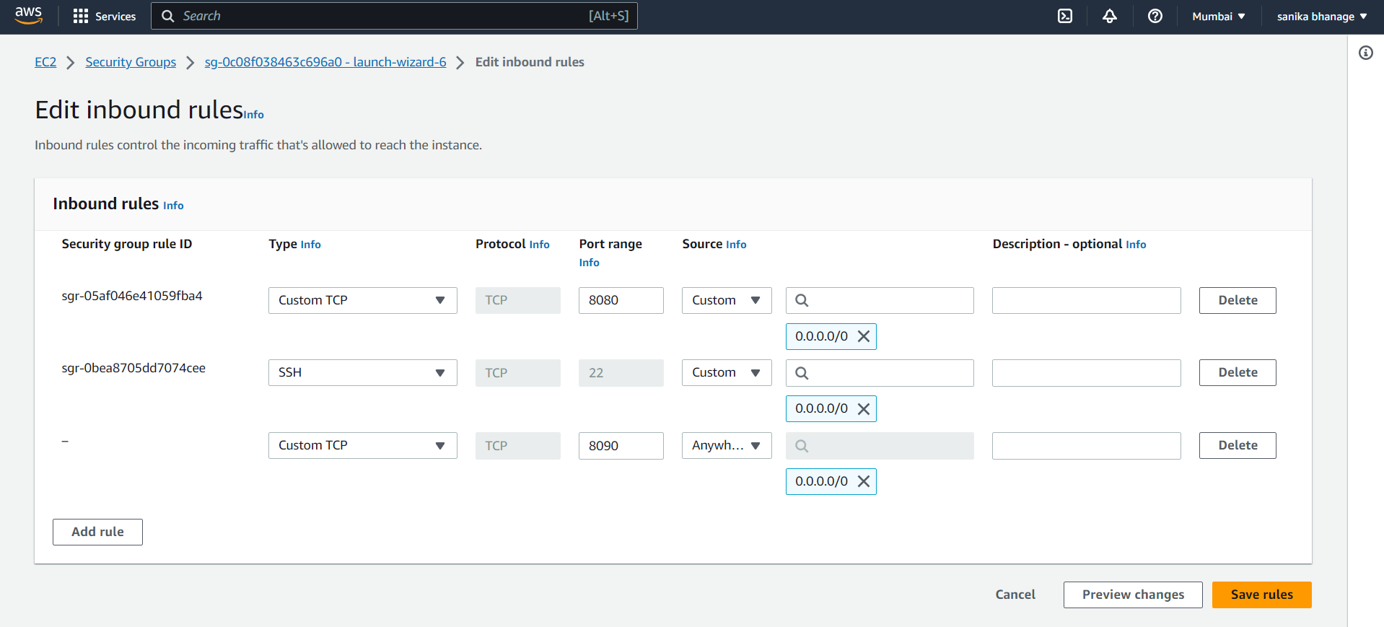

Download the tomcat latest version from its site

wget https://dlcdn.apache.org/tomcat/tomcat-9/v9.0.79/bin/apache-tomcat-9.0.79.tar.gz

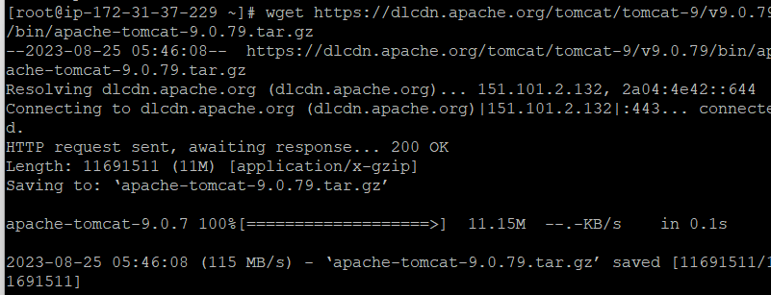

tar -xvzf apache-tomcat-9.0.79.tar.gz

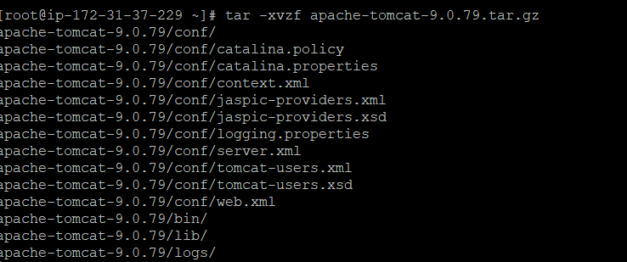

#mv apache-tomcat-9.0.79 tomcat

Got to the cd tomcat/; cd bin/; ls; you can see shutdown.sh , startup.sh Check if these files are executable or not if no then change there permissions.

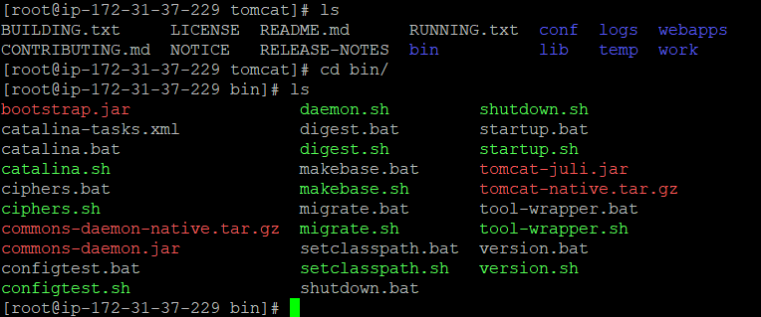

To start the tomcat server ,

./startup.sh

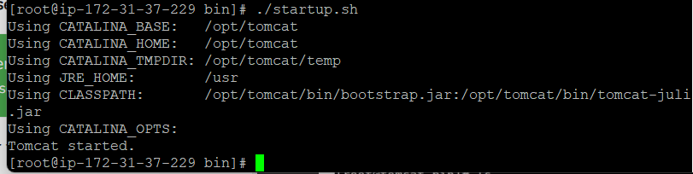

By default , tomcat allows login from local server. Hence to enable login and to change the default port to 8090 we need to find context.xml we need to change same line in both files /opt/tomcat/webapps/manager/META-INF/context.xml & /opt/tomcat/webapps/host-manager/META-INF/context.xml

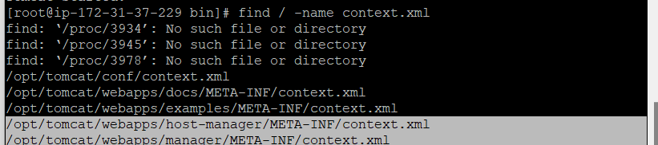

In this file you will find the line that allows only local server to login for tomcat but if we comment it out then we can able to login from out side also.

<Valve className="org.apache.catalina.valves.RemoteAddrValve"

allow="127\.\d+\.\d+\.\d+|::1|0:0:0:0:0:0:0:1" />

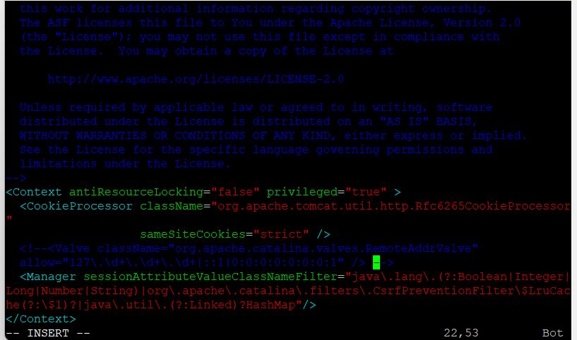

To change the default port , go to /opt/tomcat/conf/server.xml change 8080 -> 8090. Before that run shutdown.sh

./shutdown.sh

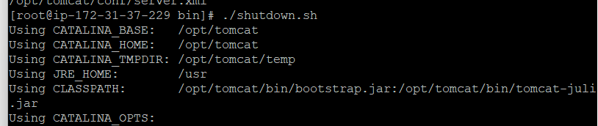

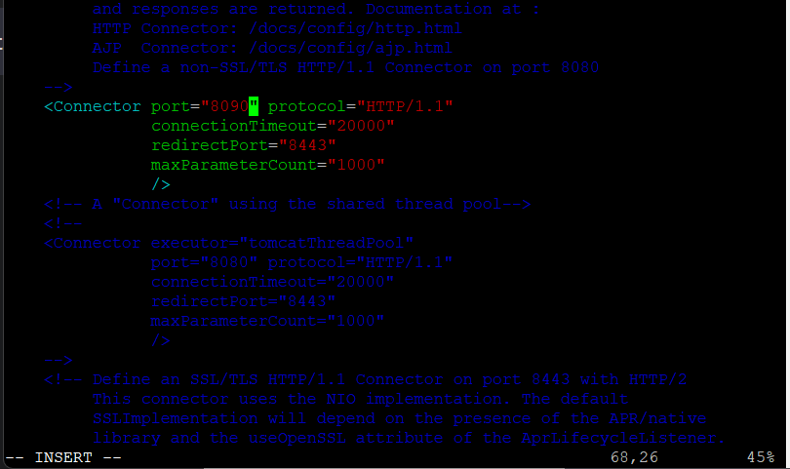

Added required roles in /opt/tomcat/conf/tomcat-users.xml.

<role rolename="manager-gui"/>

<role rolename="manager-script"/>

<role rolename="manager-jmx"/>

<role rolename="manager-status"/>

<user username="admin" password="admin" roles="manager-gui, manager-script, manager-jmx, manager-status"/>

<user username="deployer" password="deployer" roles="manager-script"/>

<user username="tomcat" password="s3cret" roles="manager-gui"/>

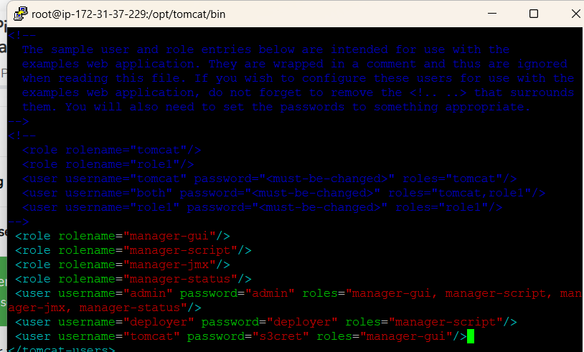

Again run shutdown.sh and startup.sh and in browser add credentials for manager-gui.

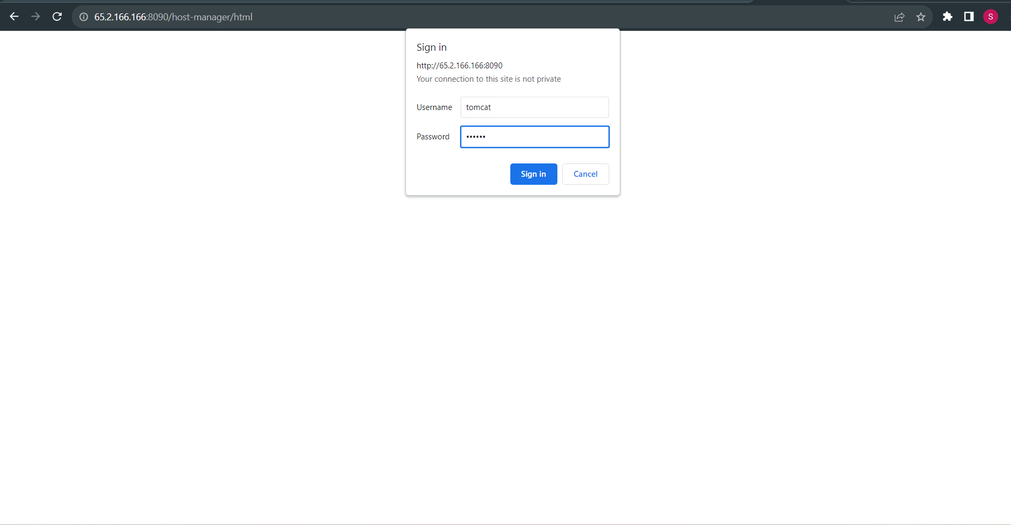

After login,

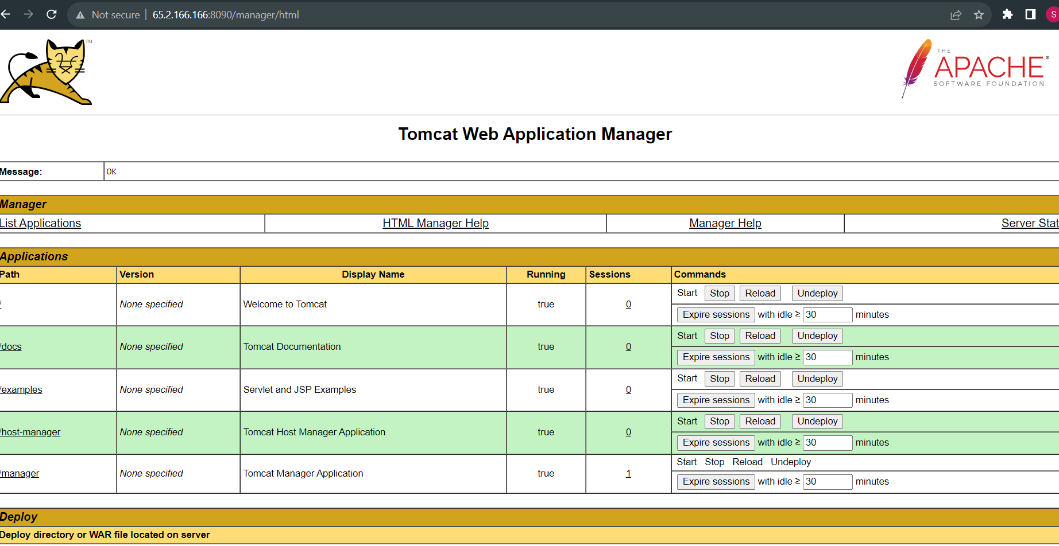

To integrate tomcat with jenkins we required plugin for tomcat in jenkins. Manage jenkins -> plugins -> Available plugins

To deploy project on any vm machine we required “deploy to container” plugin. Click on install.

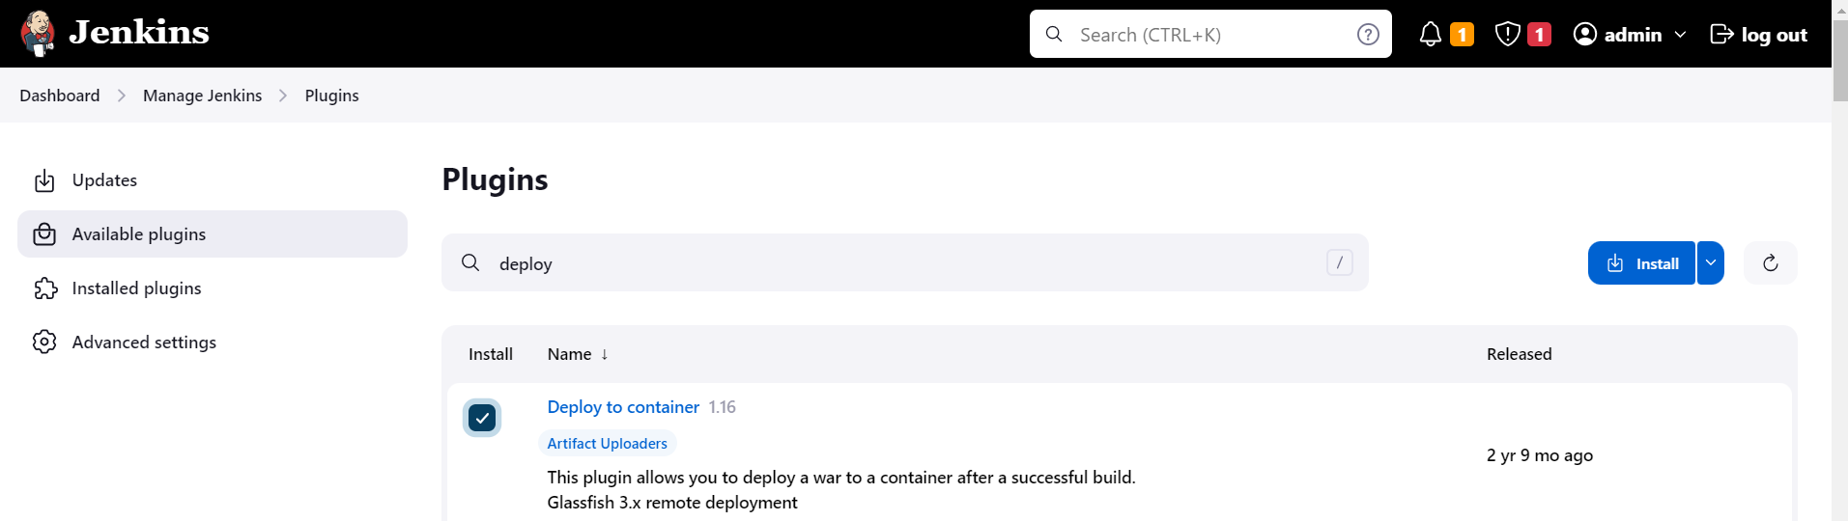

After installation build the maven job and deploy it on tomcat server. Select maven project.

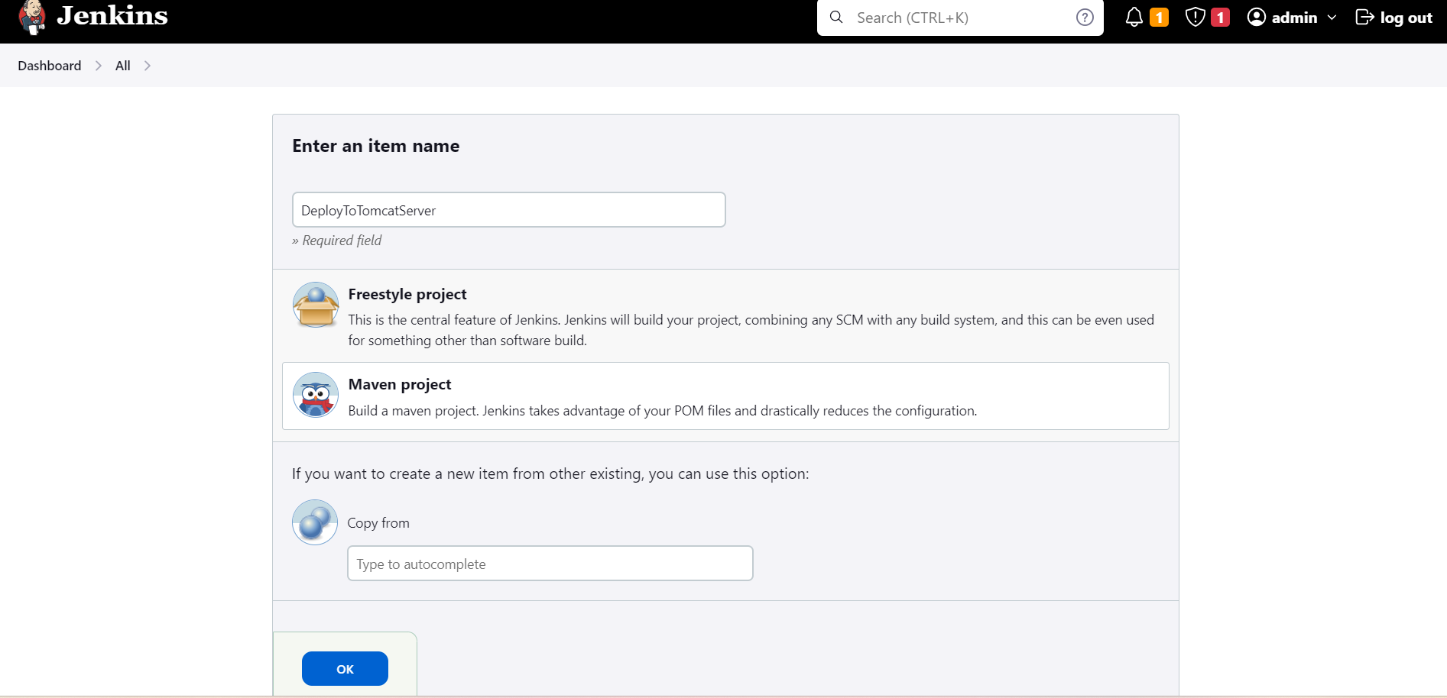

Add general job description

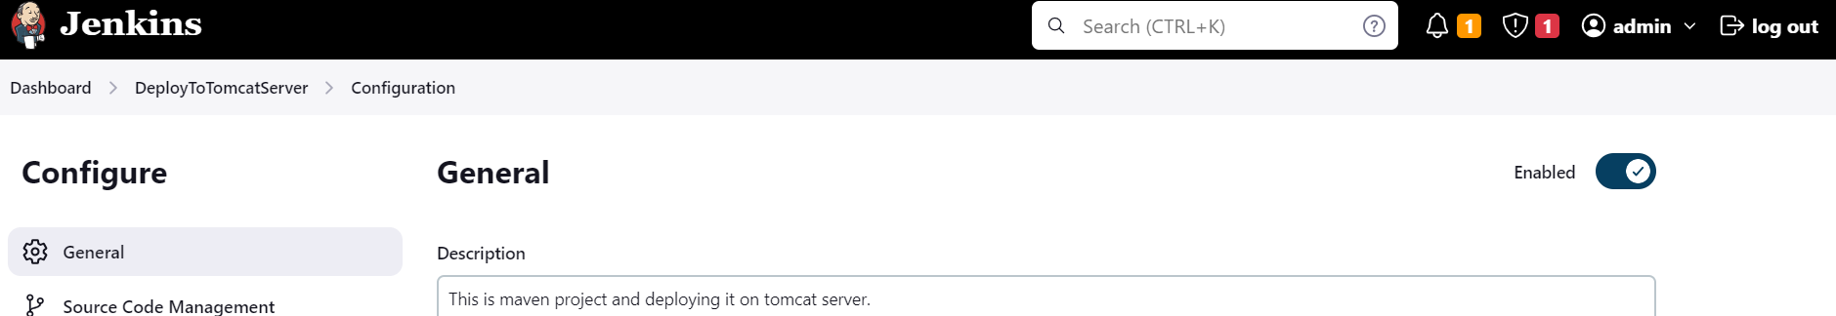

Add the github repo url

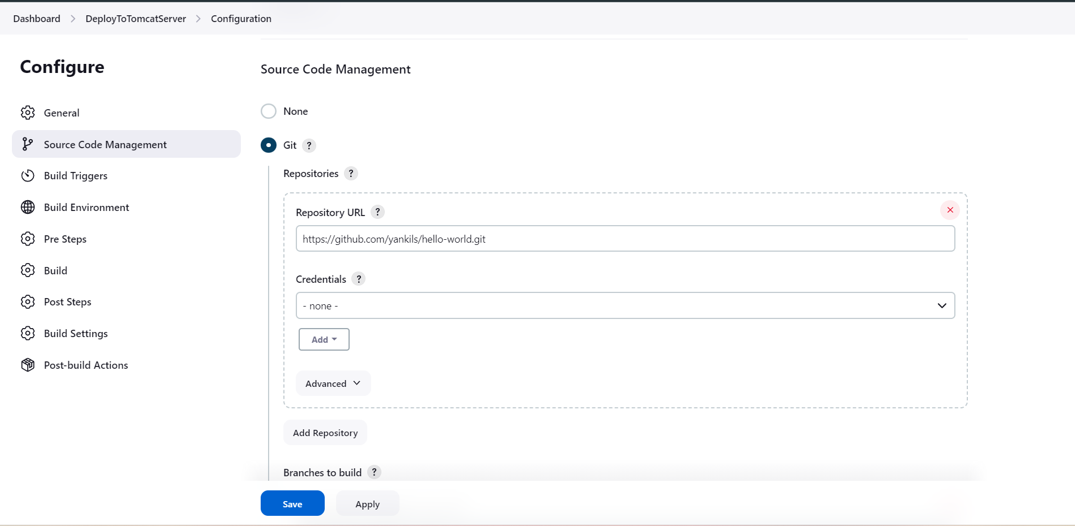

For build, pom.xml is required

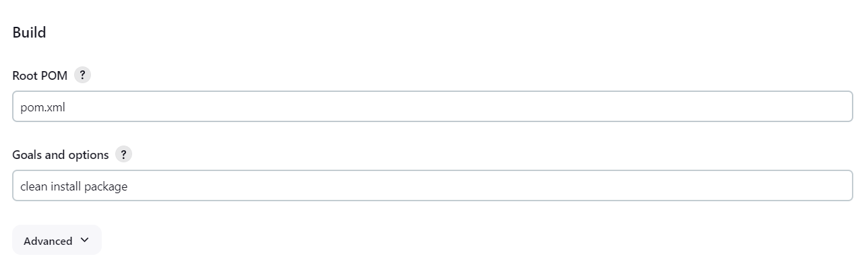

Add the war file details. If you don’t know file name simply add **/*.war

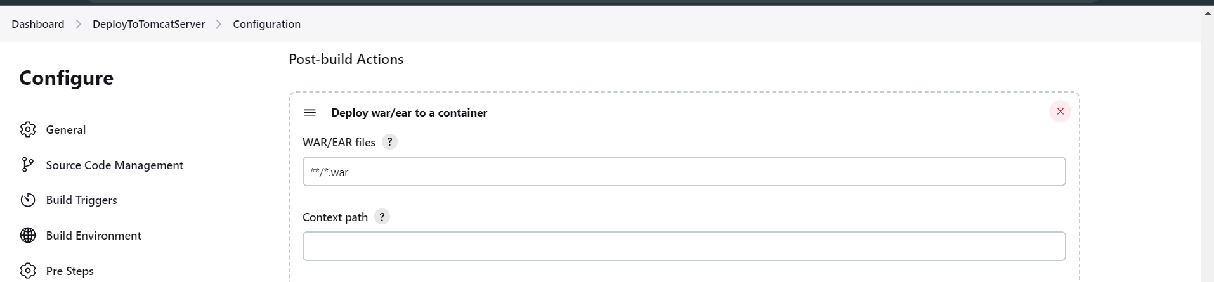

Select tomcat9 server for deployment. We have to add deployer user credential that we added already in the conf/tomcat-users.xml file. Username : deployer Password: deployer Click on save.

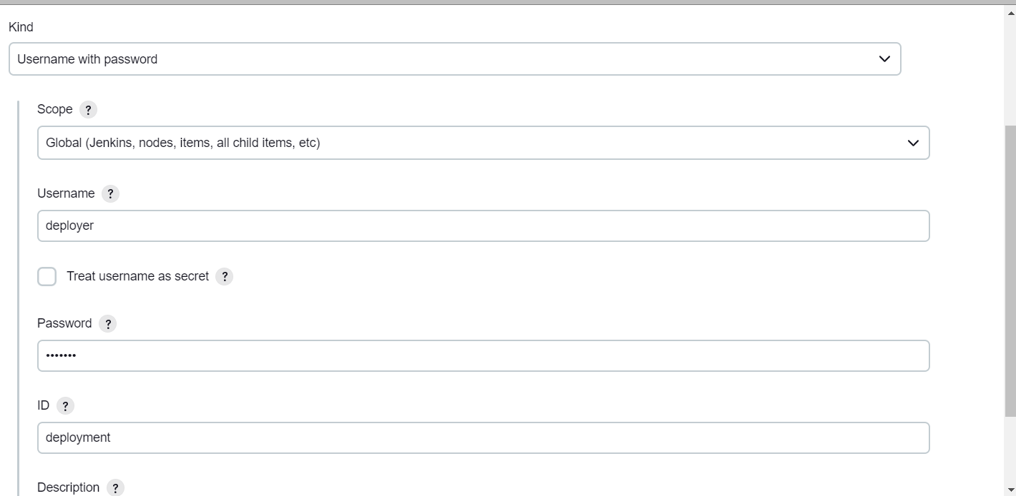

Also add tomcat url and click on apply & save and build now. In vm we can check the path for webapp where war file.

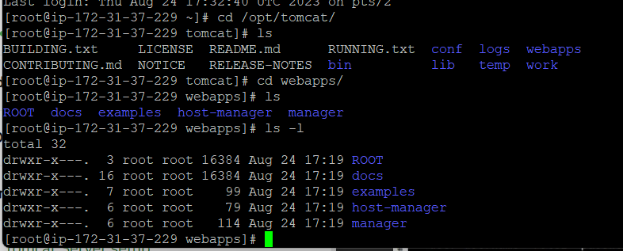

Click on apply and save and build now.

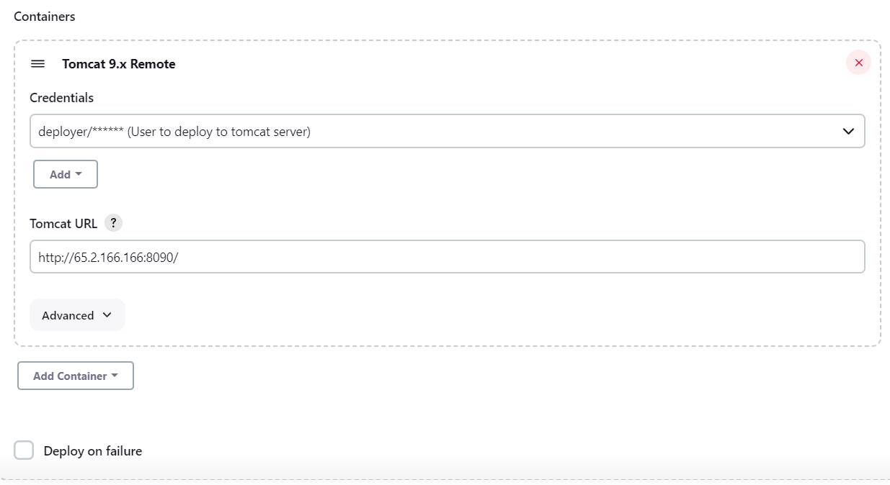

After successfully job build is done,

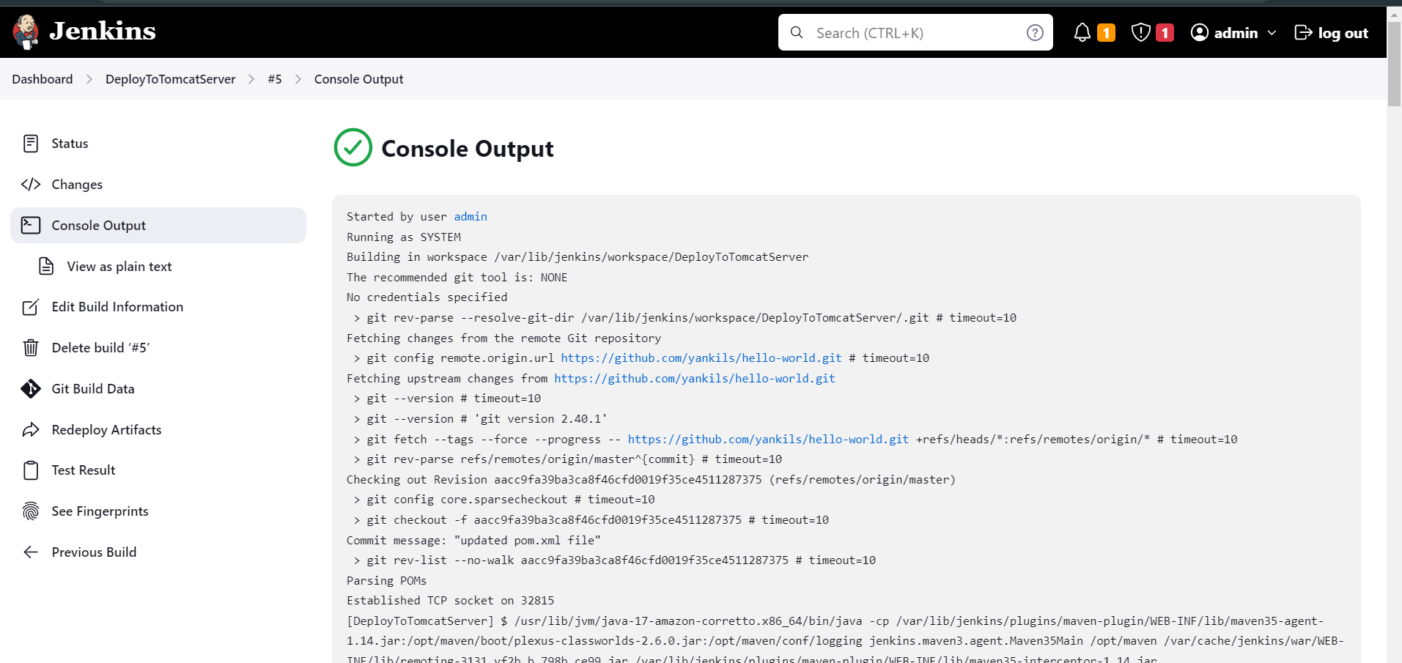

In the tomcat/webapps we can see the webapp.war file which is required project deployment.

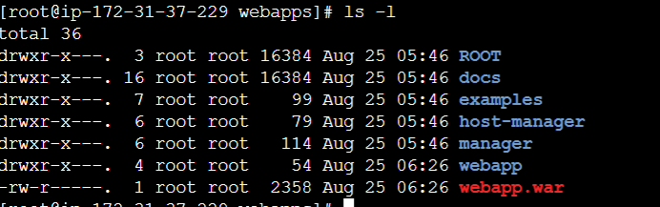

In the browser , search http://<public-ip>:8090/webapp You can see project deployed successfully on tomcat server.

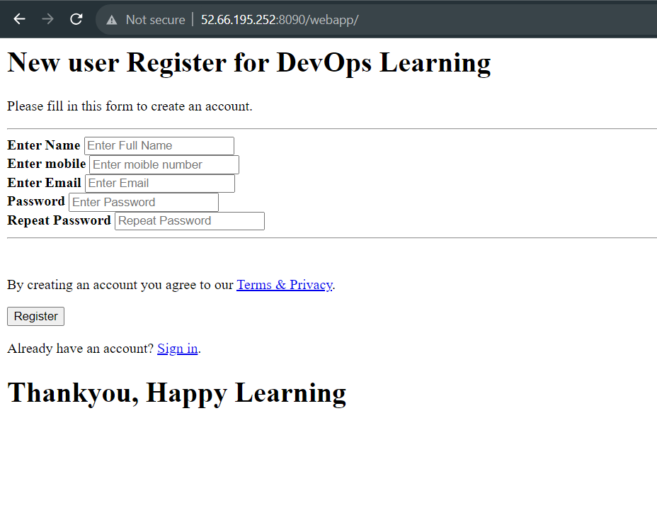

Deployment of project using POLLSCM, means job will run after specified period of time

In the Build trigger select POLL SCM ***** (every minute,every hour,every day,every month,every week) click apply save and build now

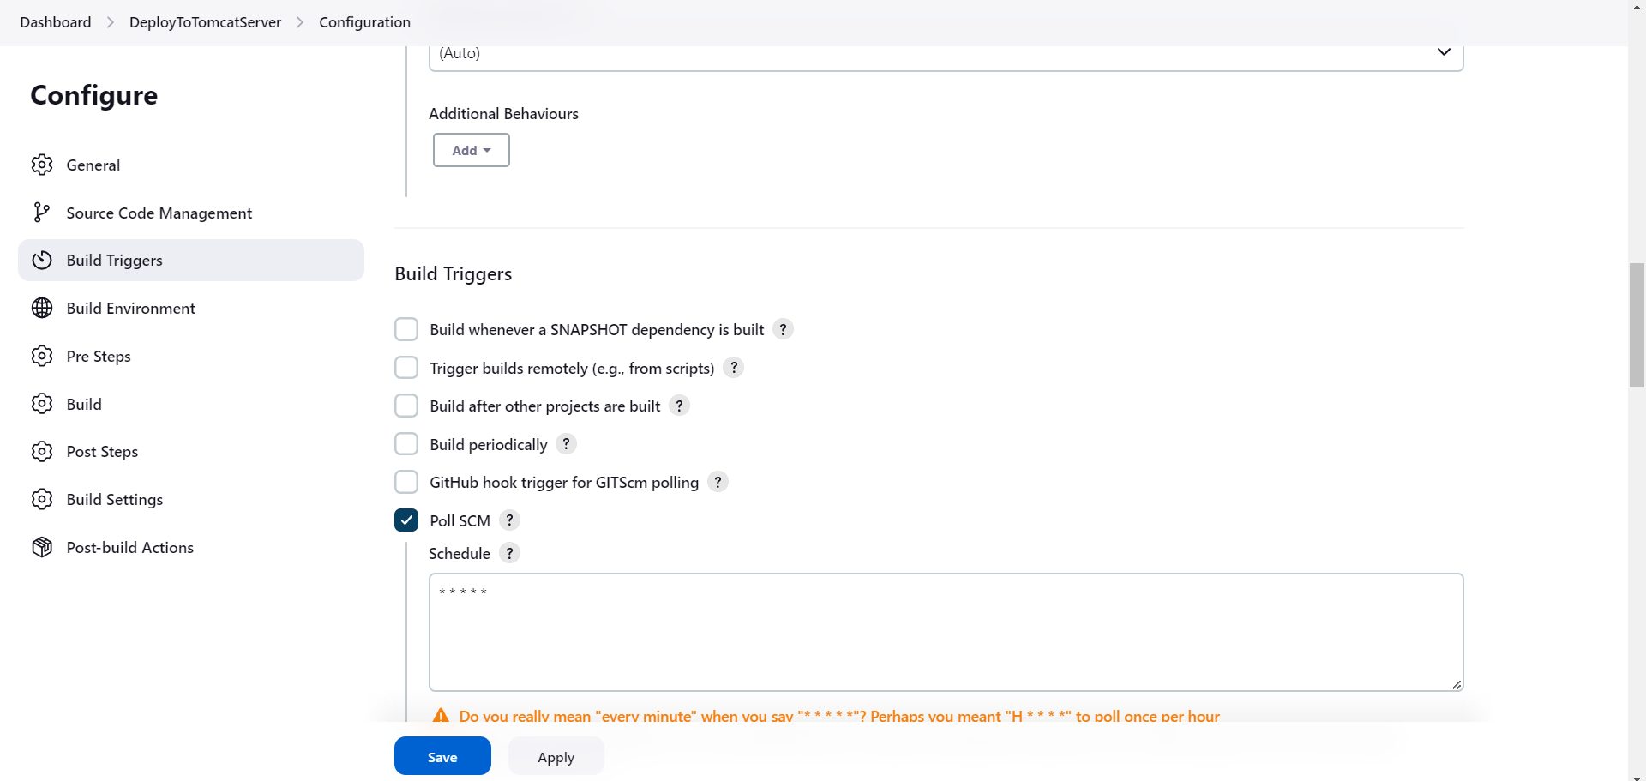

Commit the new changes in the maven project and push them to github you will see new changes occurred in webpage,

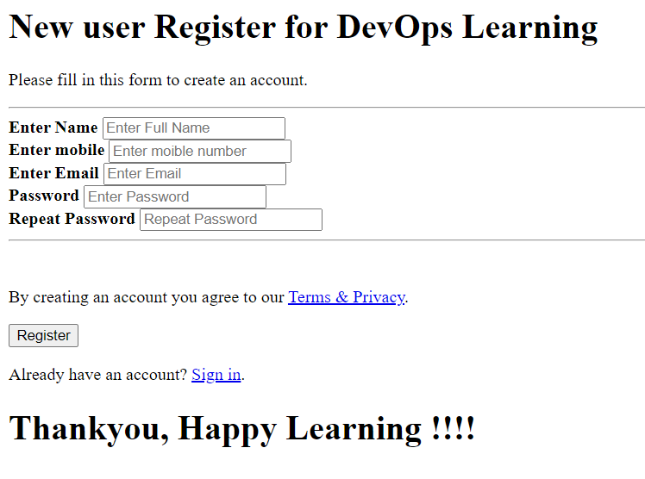

**Integrating Docker into Jenkins**

#yum install docker -y

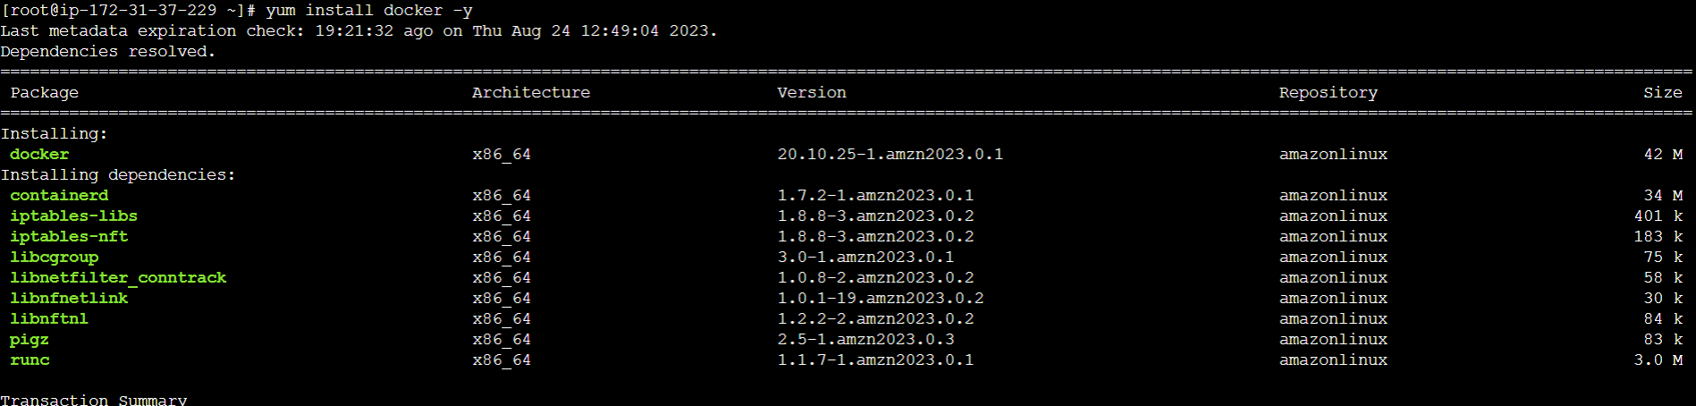

#docker -version

#service docker start

#service docker status

#systemctl enable docker

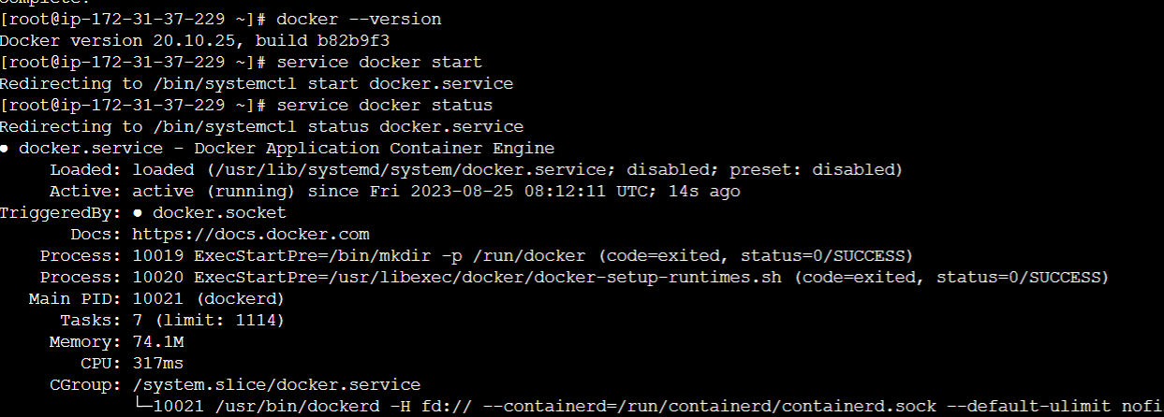

#docker pull tomcat

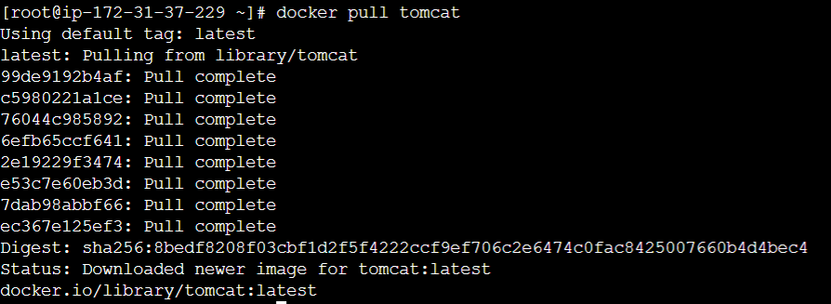

Create container using this docker image

To integrate docker into Jenkins , search plugin called as “publish over ssh” and install.

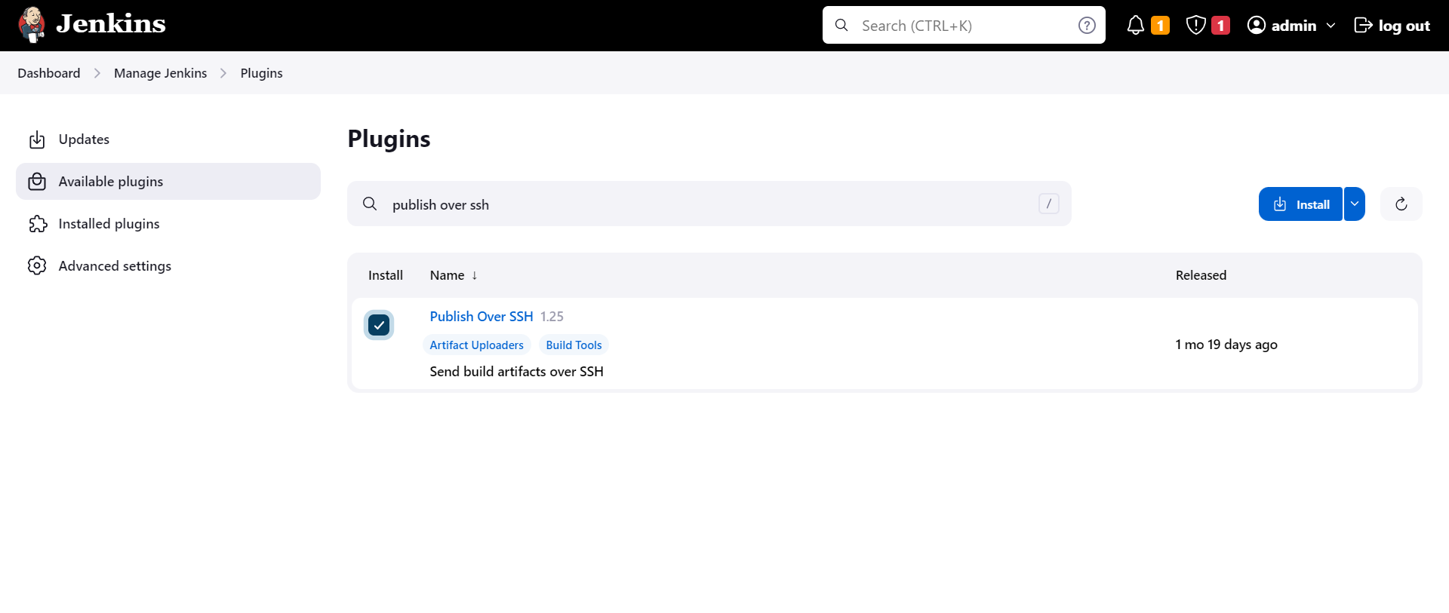

Add docker credentials

#useradd dockeradmin

#passwd dockeradmin

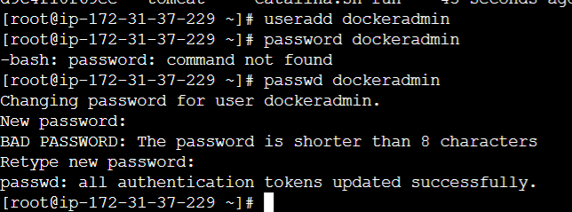

#usermod -aG docker dockeradmin

#yum install yum-utils -y

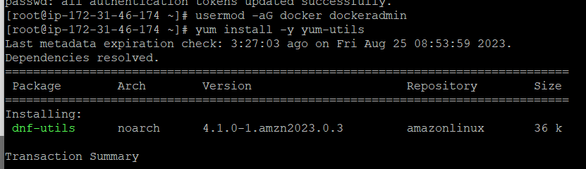

Setup docker into Jenkins

Goto the Manage Jenkins->configure->Publish over ssh-> click on add SSH Servers, provide you ip address as a hostname, dockeradmin as a user and name for the service.

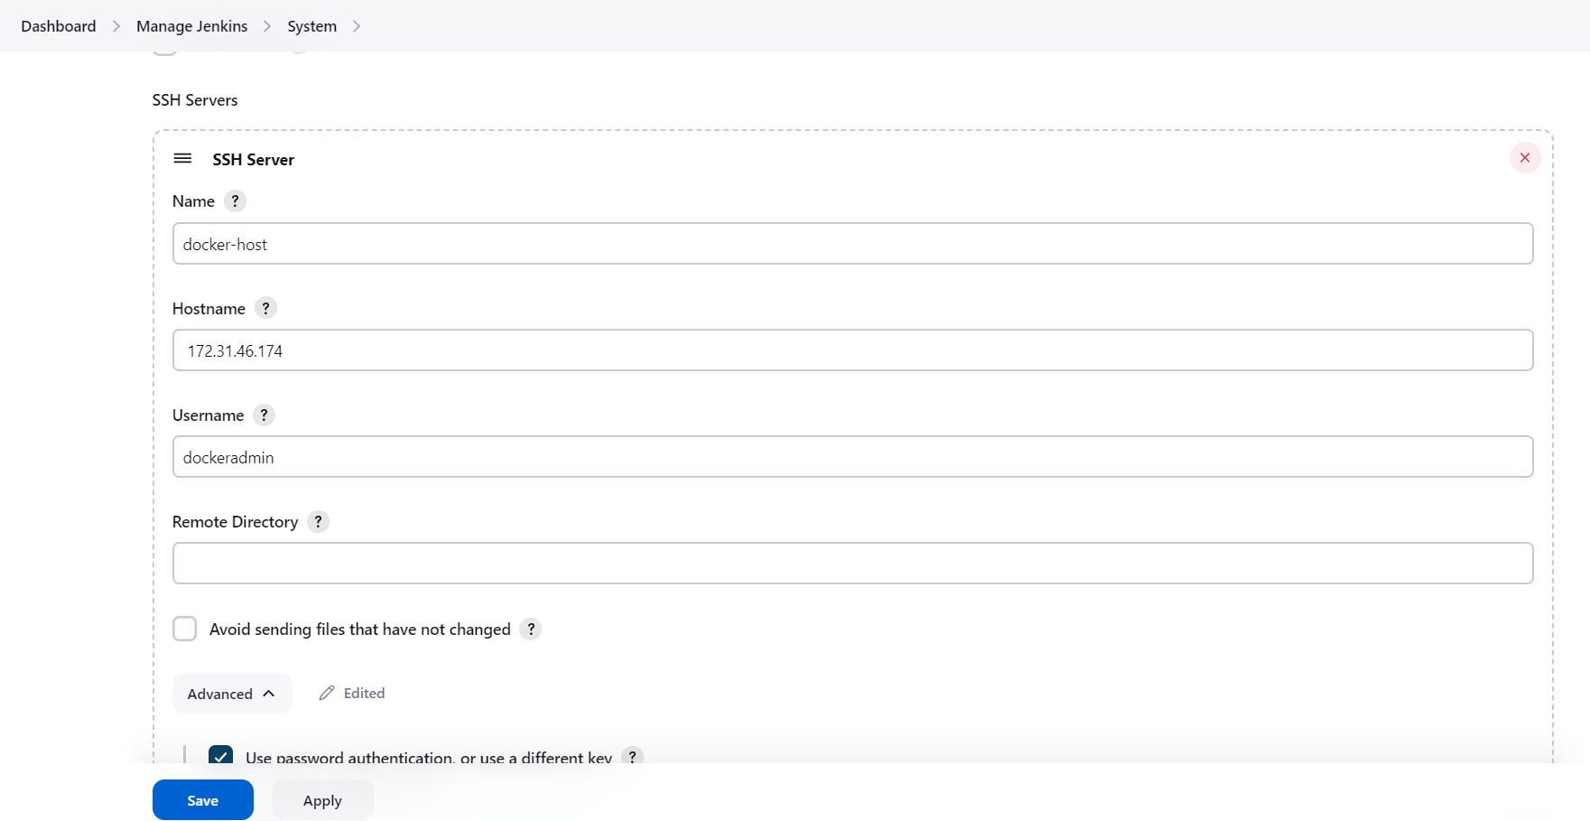

Check for ip address copy it and paste

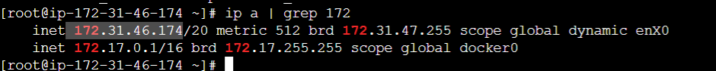

Now, we have to configure password authentication for the docker service. Hence goto your docker

In the file /etc/ssh/sshd_config change PasswordAuthentication to yes from no.

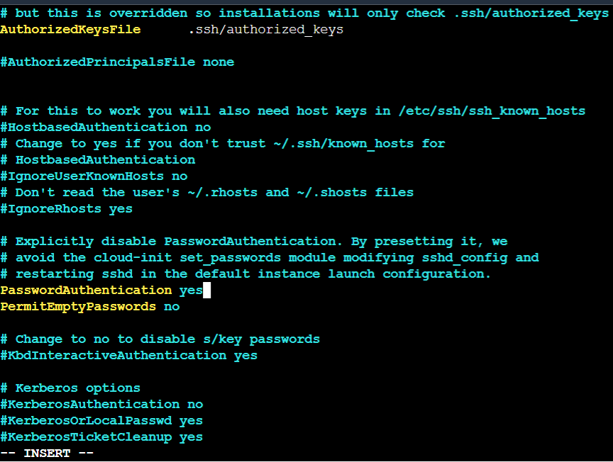

Now in Jenkins, select password authentication, provide password. And test the connection if it is successful then click on apply and save.

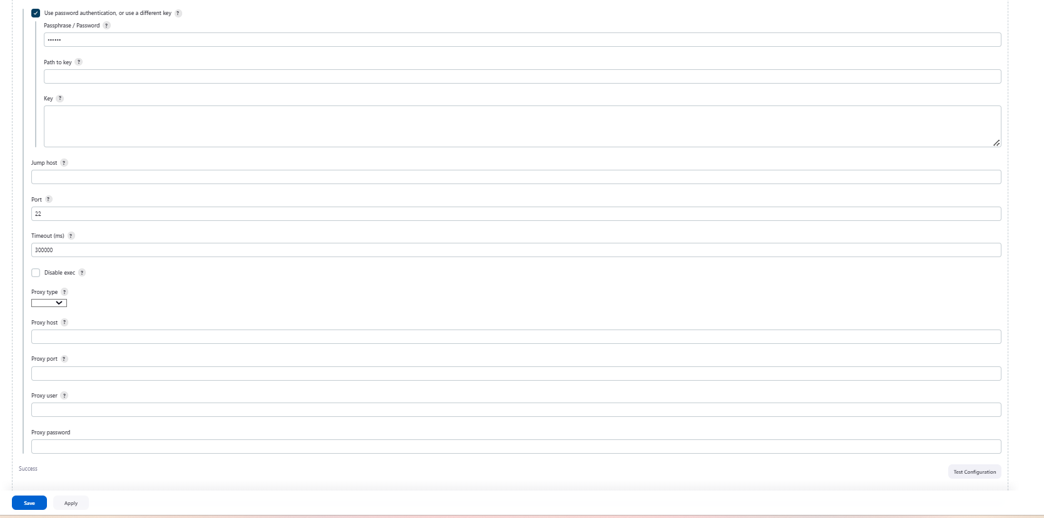

Now, to test deployment on docker create new job

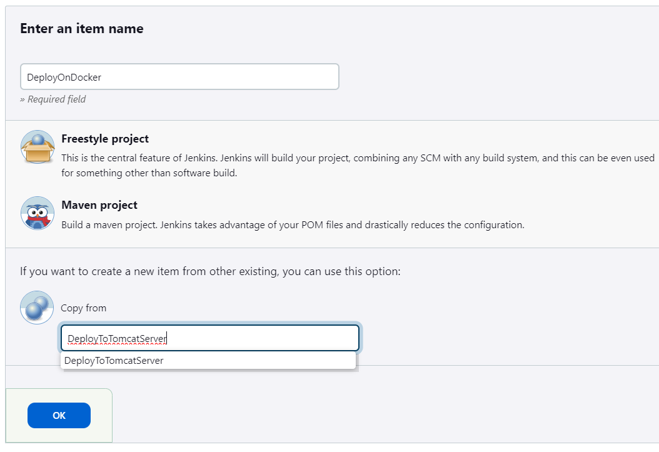

In this job, we have to build artifacts over ssh hence remove tomcat9 deployment and select build artifact over SSH.

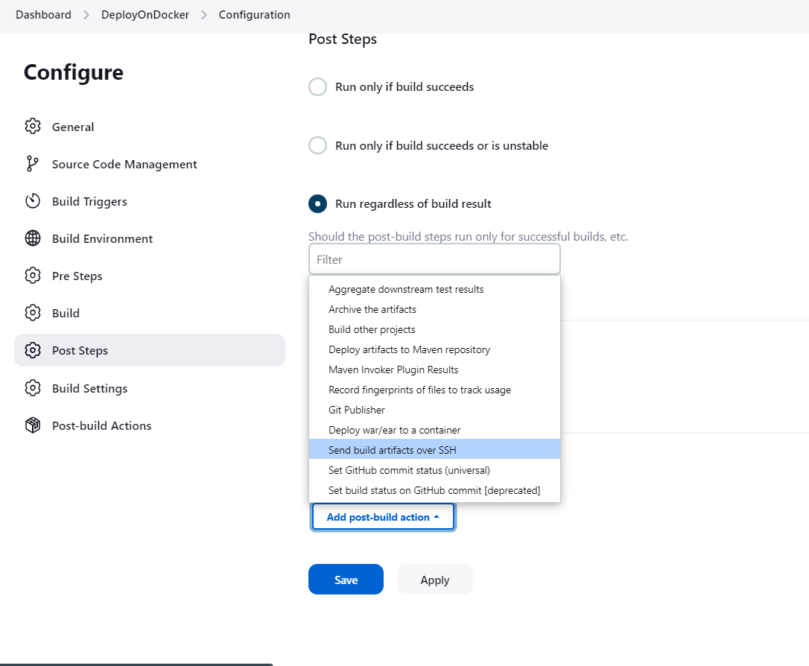

Copy the war file path and paste it , you can see that the path is in previous job build

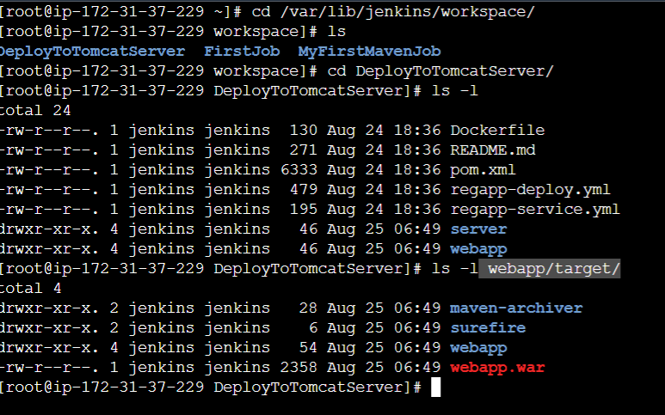

Select our SSH server , give source files webapp/target/*.war and Remote Directory is “.”

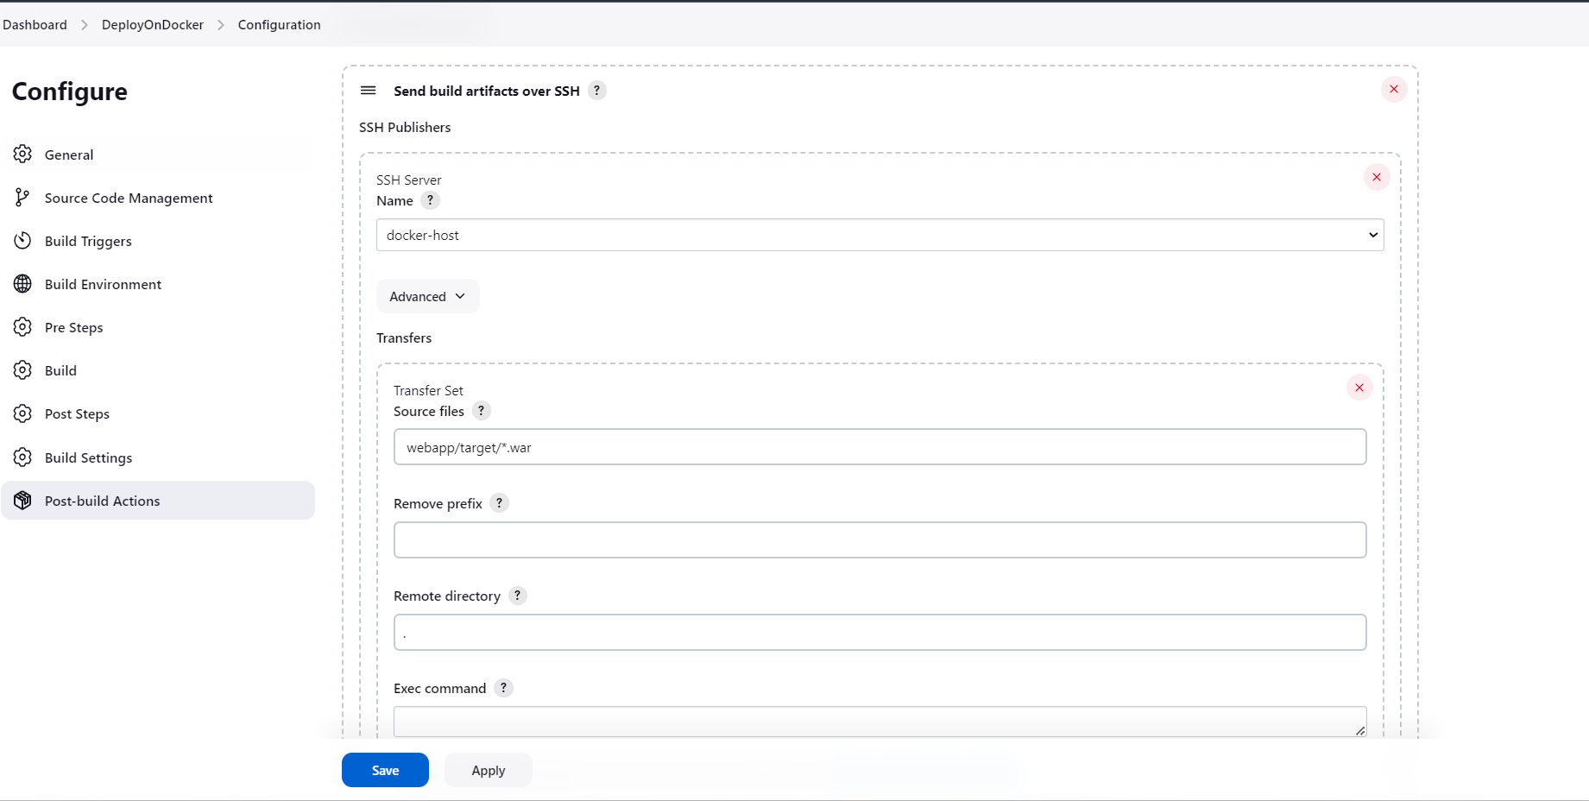

Now login as a dockeradmin to the docker ec2 instance and click on build now if the job will succefully builded then check console output.

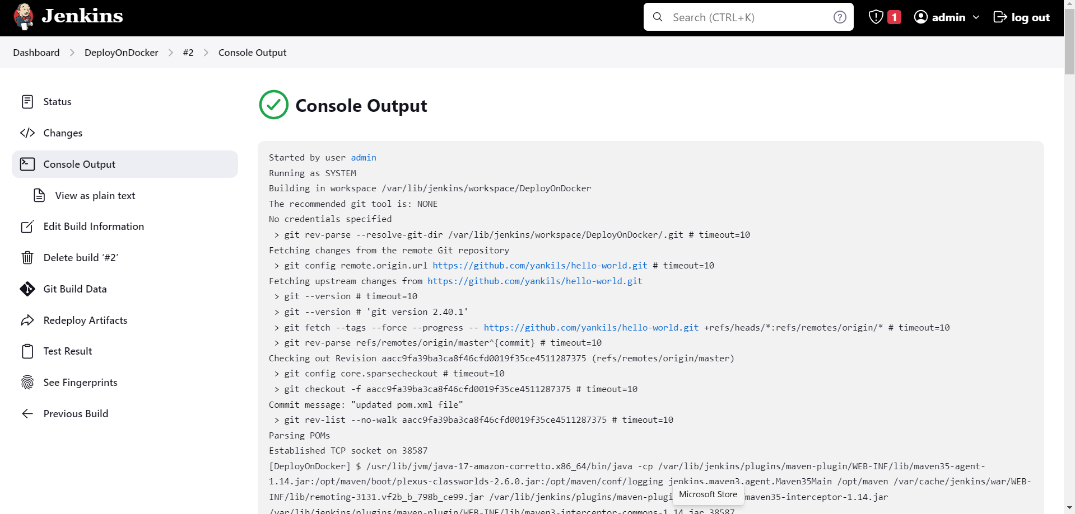

Now, on docker ec2 instance check wheather the project is run successfully. You will find this .war file.

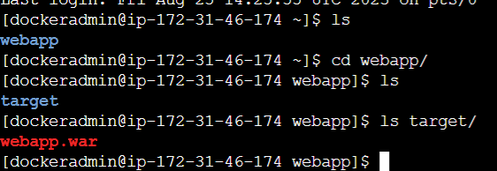

**Setup Ansible into Jenkins**

**Setup ansible environment**

First we have to create new ec2 instance setup ansible environment.

yum install python

yum install python-pip

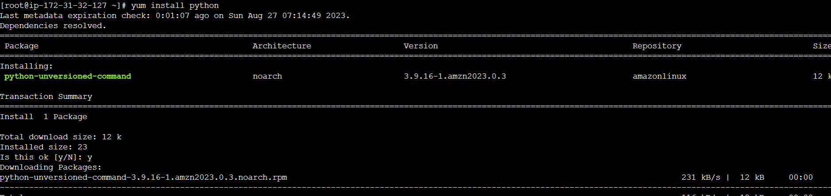

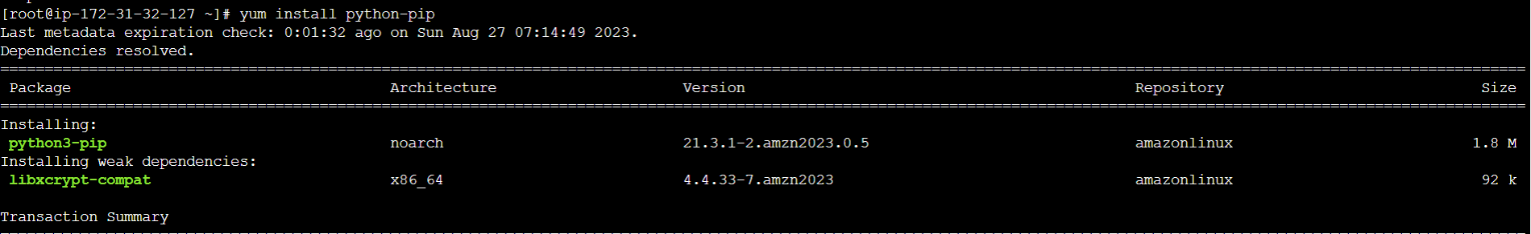

pip install ansible

ansible --version

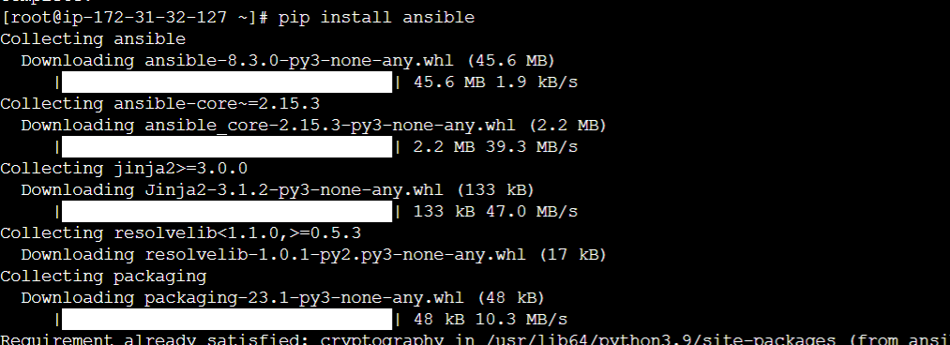

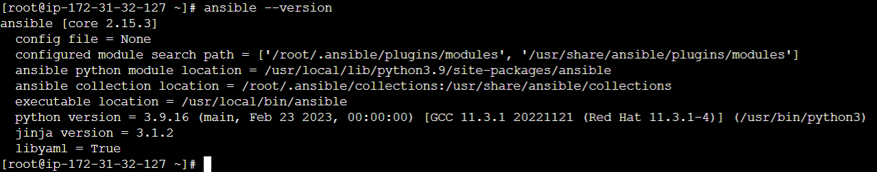

#mkdir /etc/ansible

#useradd ansadmin

#passwd ansadmin

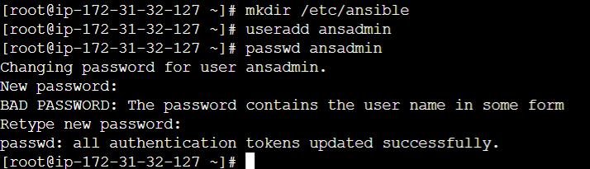

echo "ansadmin ALL=(ALL) NOPASSWD: ALL" >> /etc/sudoers using this add this user to sudoers file. (create this ansadmin on the docker ec2 instance also and add this entry.)



Make key-based authentication hence change PasswordAuthentication to yes. (same service reload and password auth must have to be done on docker ec2 instance)

sed -ie 's/PasswordAuthentication no/PasswordAuthentication yes/' /etc/ssh/sshd_config

service sshd reload



Ansible server used to create images and store on docker registry. Hence install docker, start docker services and add ansadmin to the docker group.

yum install docker

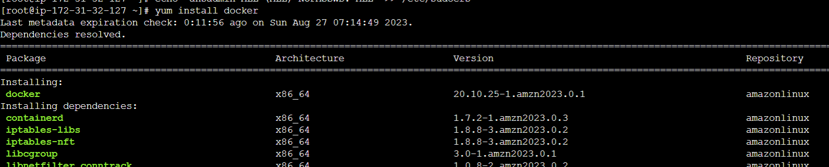

service docker start

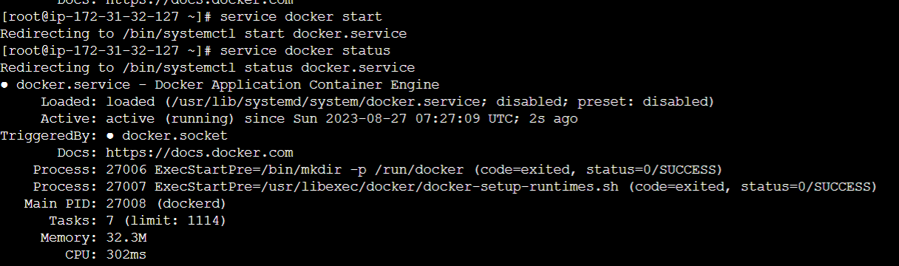

usermod -aG docker ansadmin (same command also run on docker ec2 instance)

systemctl enable docker



To generate keys for ansadmin user

su – ansadmin

ssh-keygen

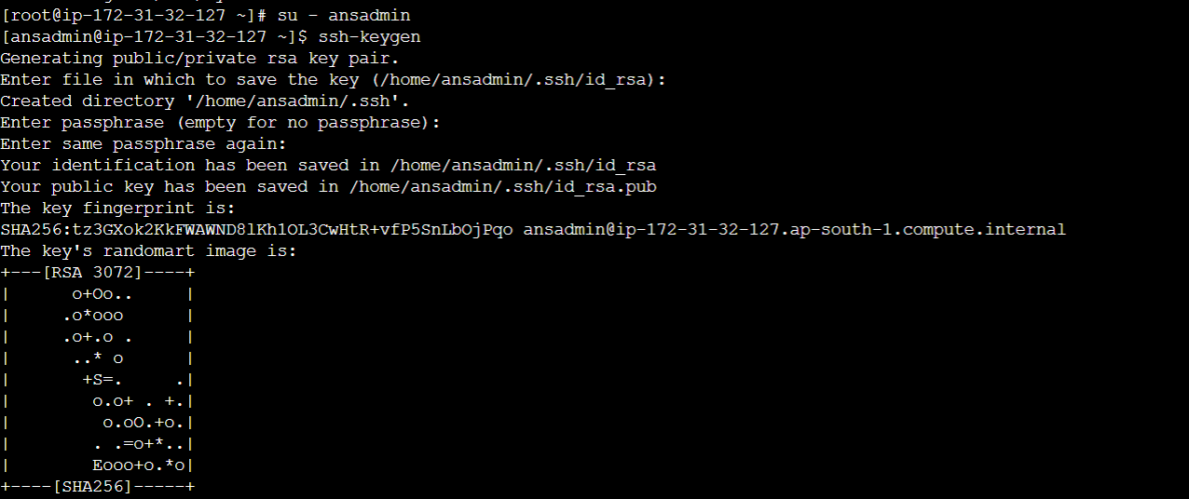

Now , go to the docker instance ec2 create ansadmin user and give same password for this user as provided in the ansible instance ec2. Now come to the ansible instance ec2 and try to copy public key to the docker instance ec2

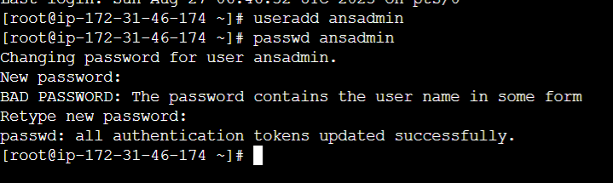

ssh-copy-id ansadmin@<target-server>

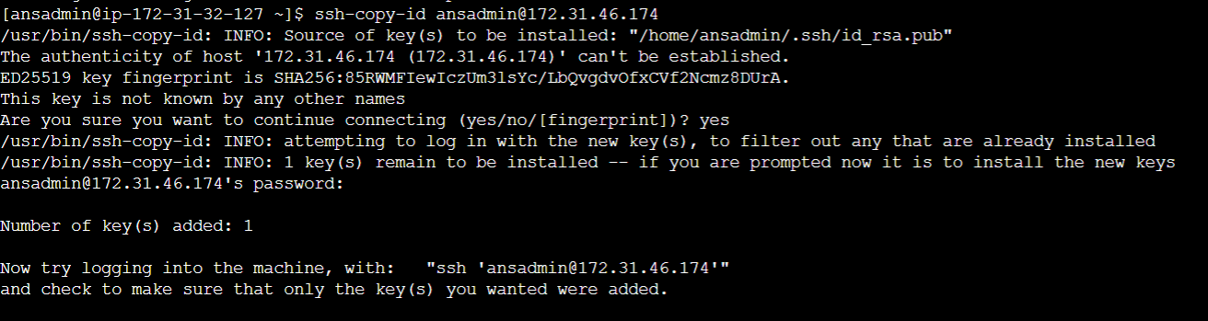

Test the connectivity ssh ansadmin@<target-server>

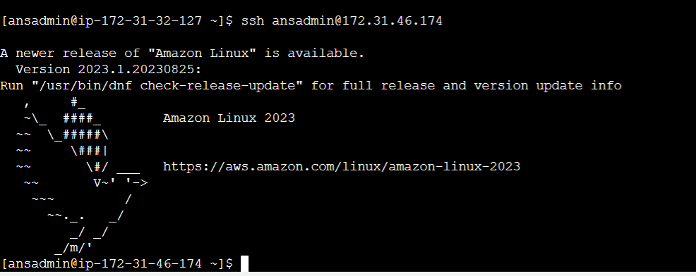

Also copy id for localhost

#ssh-copy-id localhost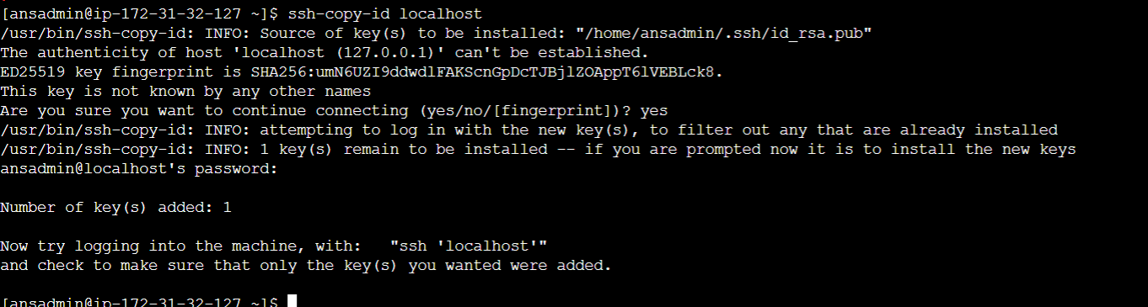

Add hosts entries for ansible (add first entry private ip of docker ec2 instance and second is localhost)

#sudo vi /etc/ansible/hosts

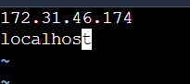

Test the connections by ping

#ansible all -m ping (-m means modules)

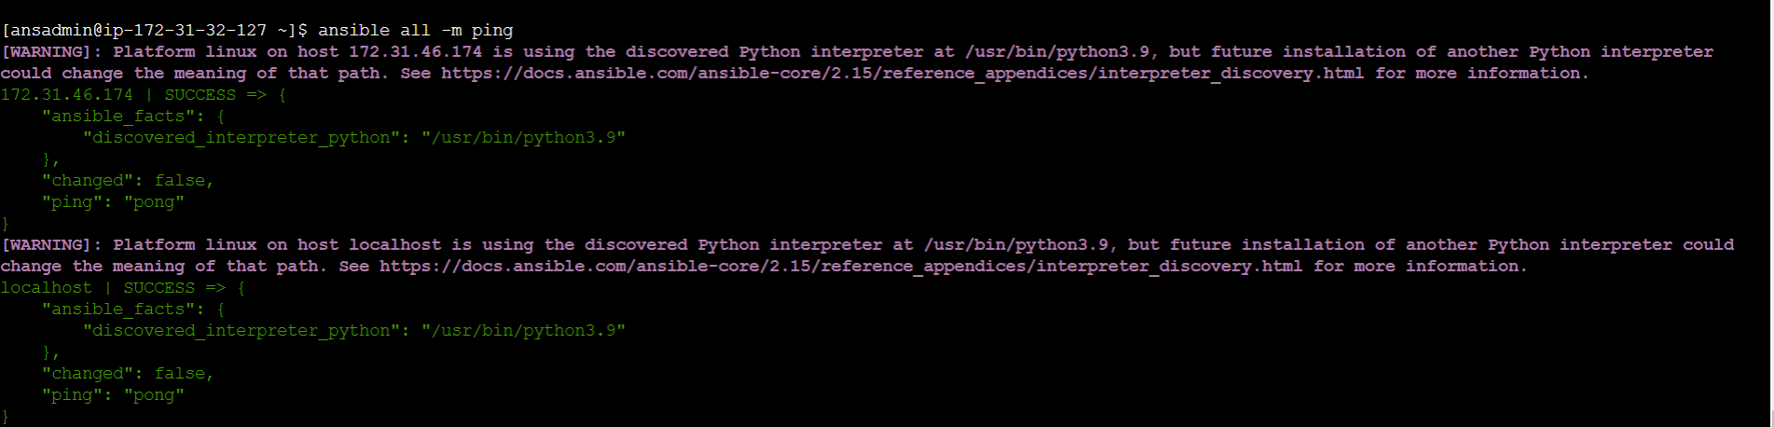

Integrate Ansible into Jenkins

Go to Jenkins dashboard -> Manage Jenkins -> configure

Add name as ansible-server , hostname as private ip of ansible server, username as ansadmin , click on Advanced setting and select password authentication then add the password for the user ansadmin.

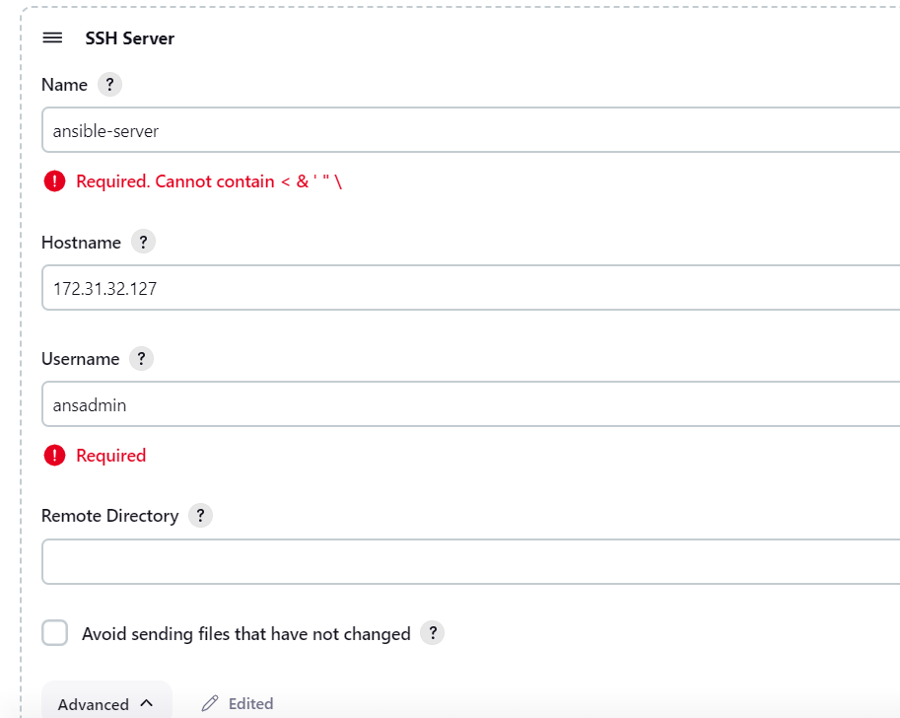

And provide its password.

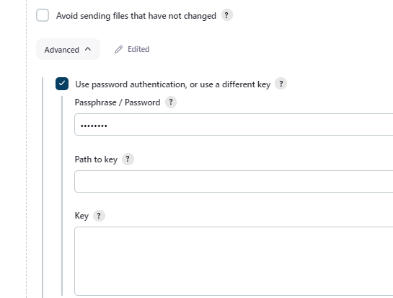

Click on test connection .click on apply and save

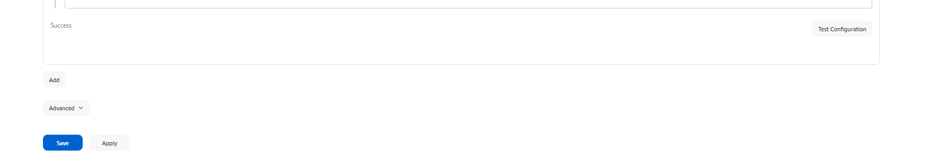

Now, to test the our setup create new job as DeployOnContainerUsingAnsible

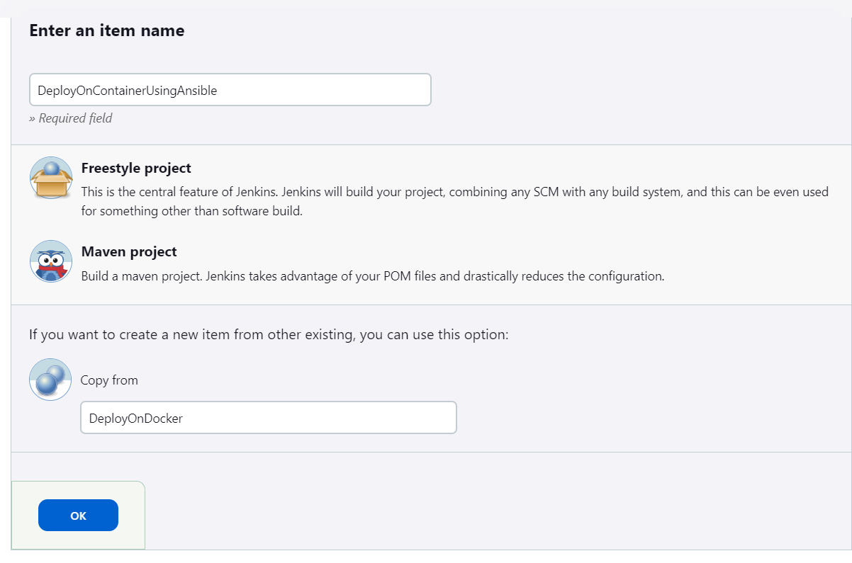

In this job change in the SSH-server select ansible-server instead of docker-host and to store the build instead of home directory we will create new one and changed its ownership to ansadmin

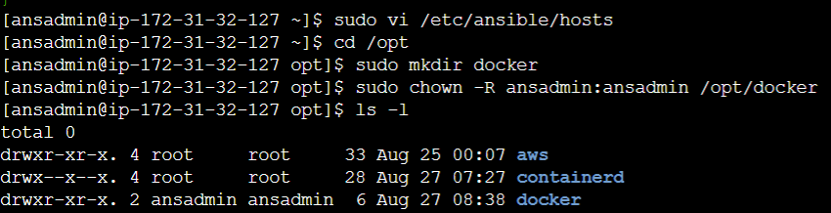

In the SSH-server give remote directory name with //opt/docker click on apply and save and build now.

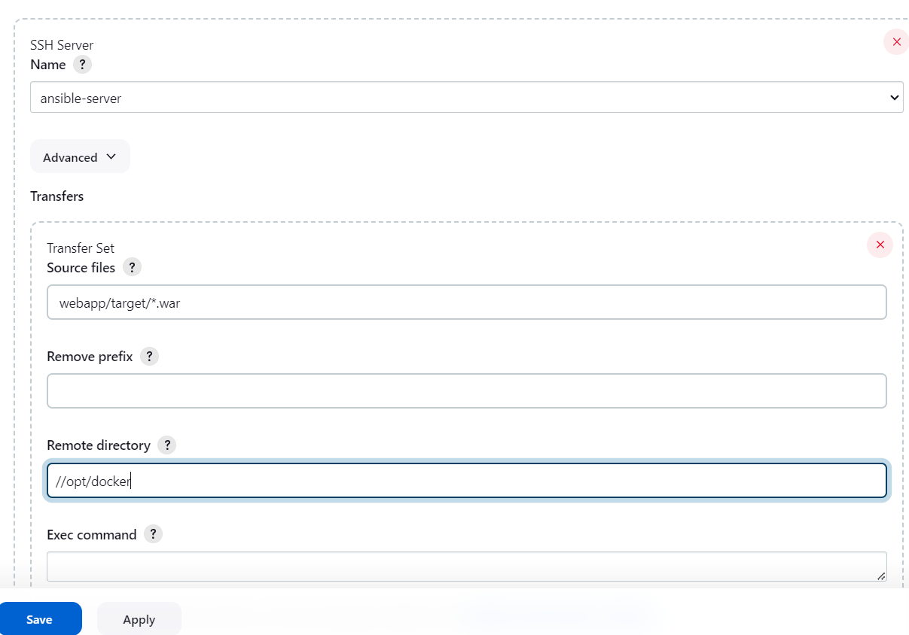

You can see console output of the job that it is builded successfully.

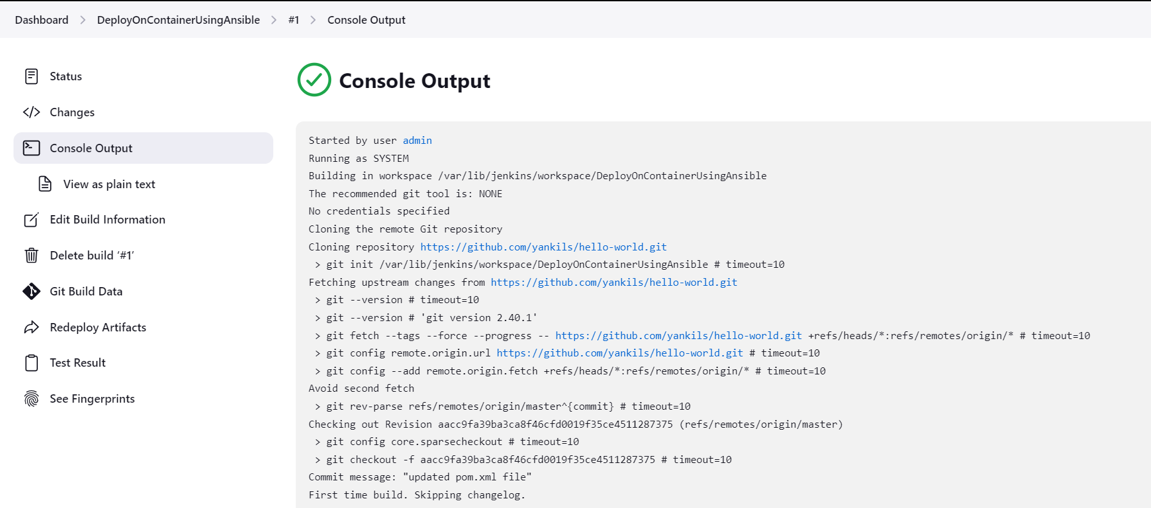

You can see on the ansible server under /opt/docker we can get war file of the project.

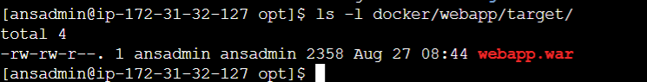

Now ,our task is to automate the job using ansible hence we have to write playbook for ansible

#cd /opt/docker

#sudo vi Dockerfile

FROM tomcat:latest

COPY ./webapp.war /usr/local/tomcat/webapp

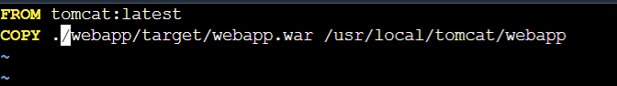

#vi simple-devops-project.yml

---

- hosts: all

become: true

tasks:

- name: building docker image

command: docker build -t simple-devops-image .

args:

chdir: /opt/docker

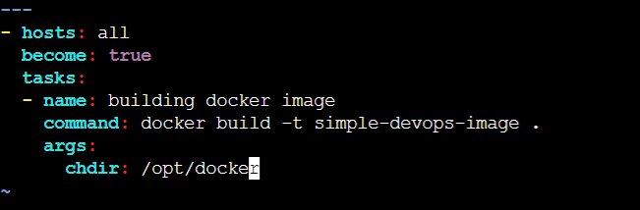

We have to create image only on localhost and can deploy on both hence create again new hosts file in same directory.

#vi hosts

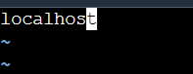

Check ansible playbook file

ansible-playbook -i hosts simple-devops-image.yml --check

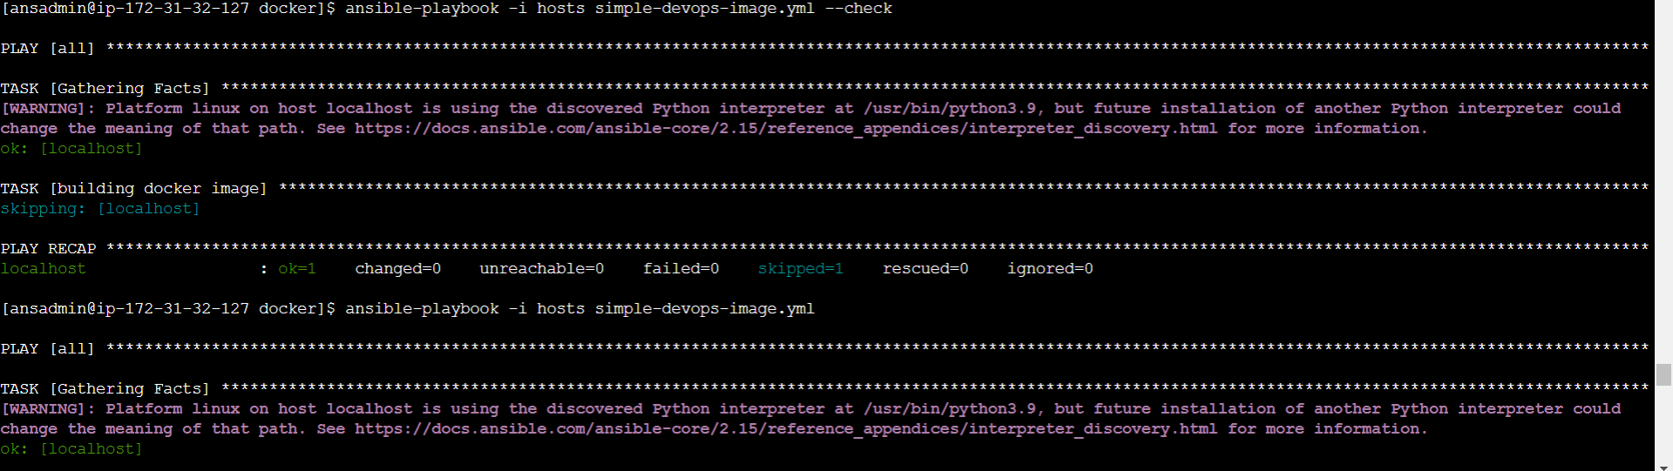

Now run the file

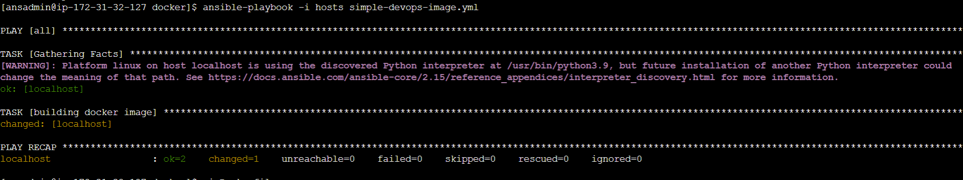

#docker images you can see 2 images one is tomcat and other is using tomcat -> simple-devops-project

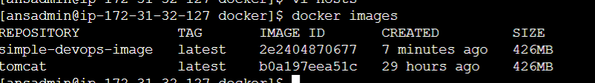

Now to run the container using this image

#vi simple-devops-image.yml add the following lines

- name: create simple-devops-container

command: docker run -d --name simple-devops-container -p 8080:8080 simple-devops-image

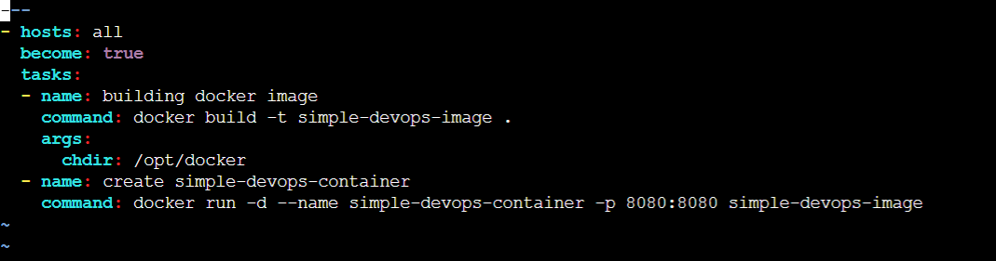

Now , rename this file because container will create again.

mv simple-devops-image.yml simple-devops-project.yml

ansible-playbook -i hosts simple-devops-project.yml

docker ps

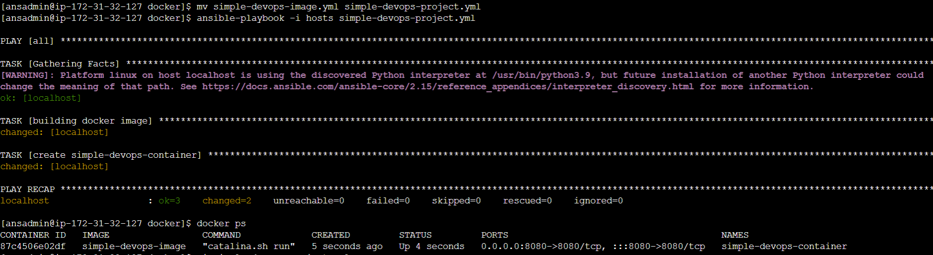

Now, to automate using Jenkins , delete you container created using simple-devops-image , simple-devops-project, tomcat images. And also these images.

#docker stop container-name

#docker rm container-name

#docker rmi tomcat simple-devops-image simple-devops-project

Now, goto our previous job DeployOnContainerUsingAnsible and edit the SSH-Server add full path of the yml file.

Give full path in executable command

ansible-playbook -i /opt/docker/hosts /opt/docker/simple-devops-project.yml;

Now build the job.

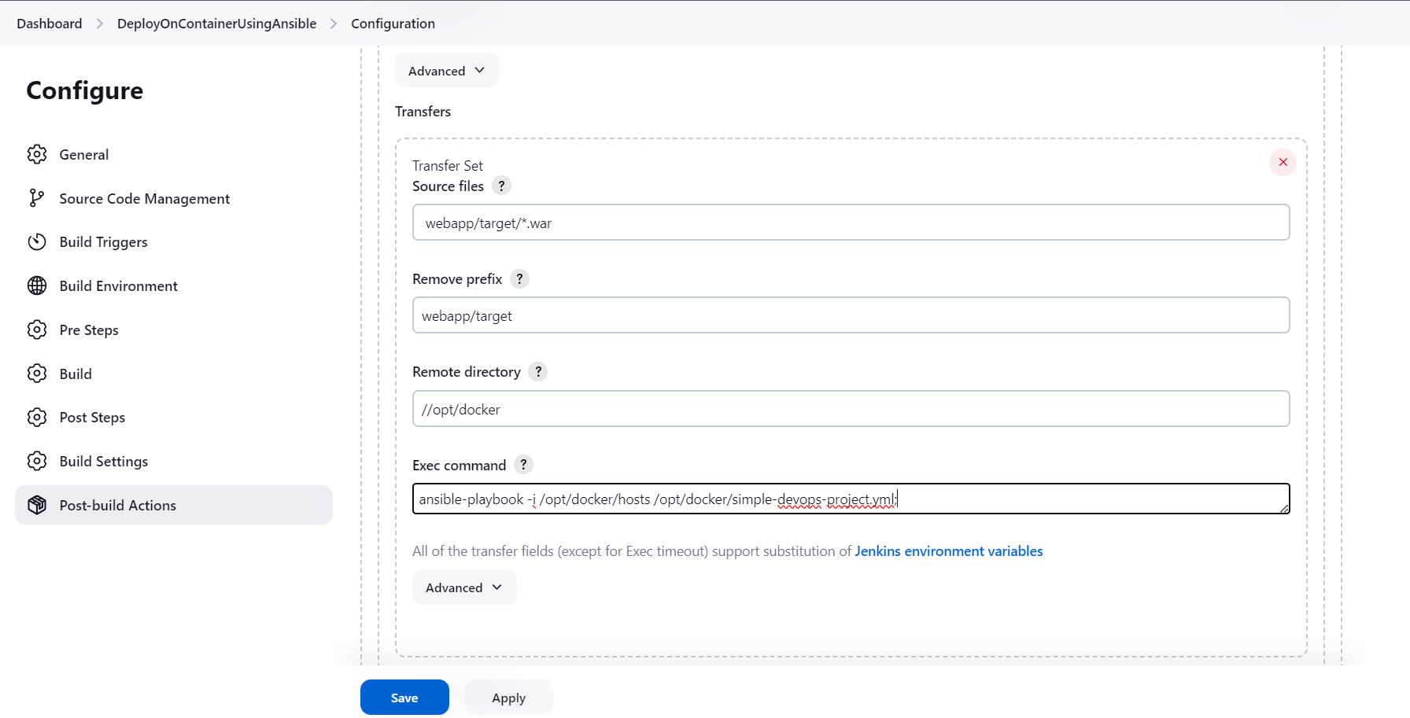

You can check console output.

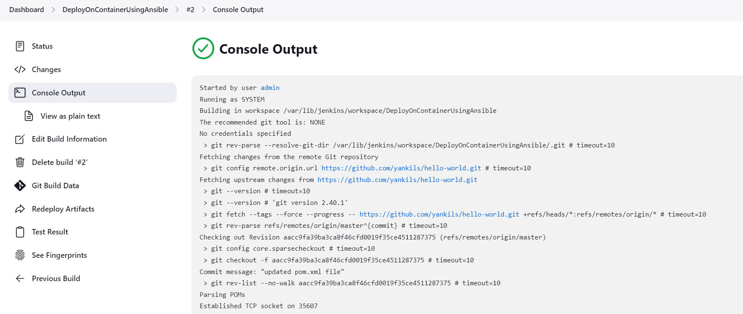

Now, check wheather the container is running or not and in browser check using ansible ip:8080/webapp



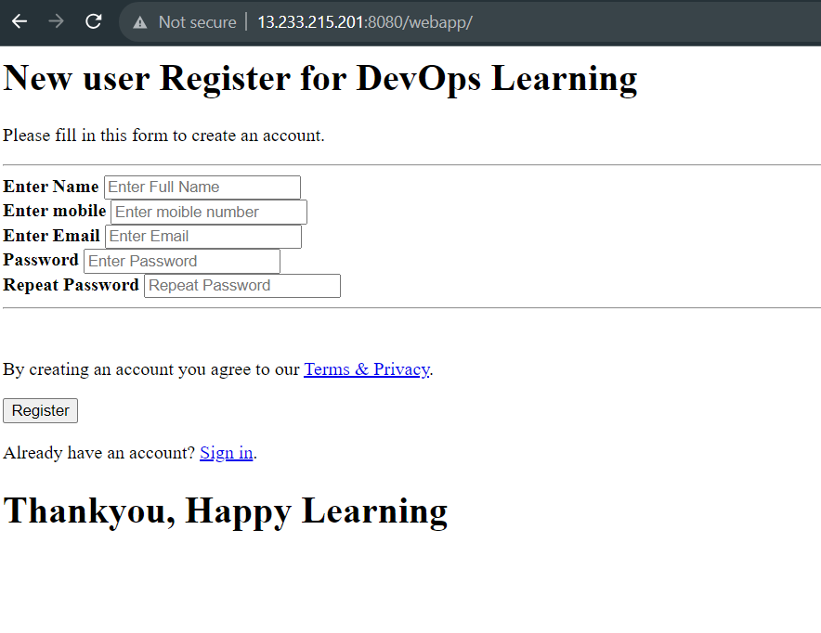

Now change your code and push it try to run job it will show unstable because already there is container running with same container.

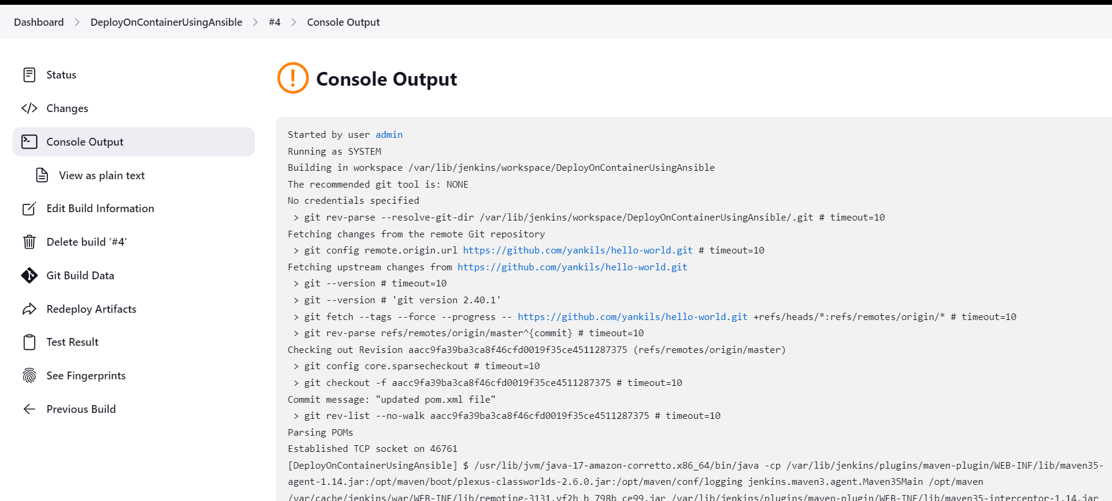

Hence we need to change our ansible book

- name: stop if we have old docker container

command: docker stop simple-devops-container

ignore_errors: yes

- name: remove stopped docker container

command: docker rm simple-devops-container

ignore_errors: yes

- name: remove current docker image

command: docker rmi simple-devops-image

ignore_errors: yes

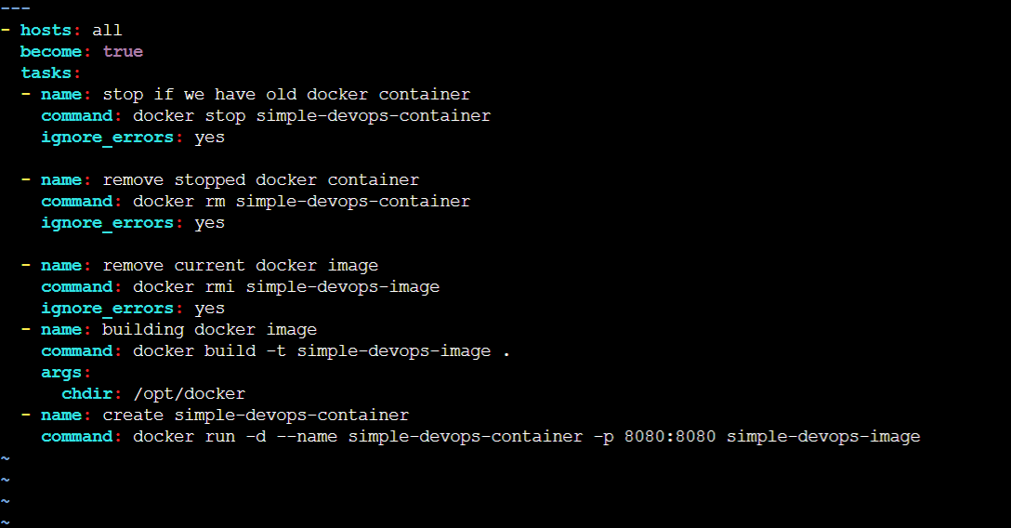

In the jenkins job, change SSH-server

Add source files: webapp/target/*.war

Remove prefix: webapp/target

Remote Directory://opt/docker

Exec command: ansible-playbook -i /opt/docker/hosts /opt/docker/simple-devops-project.yml;

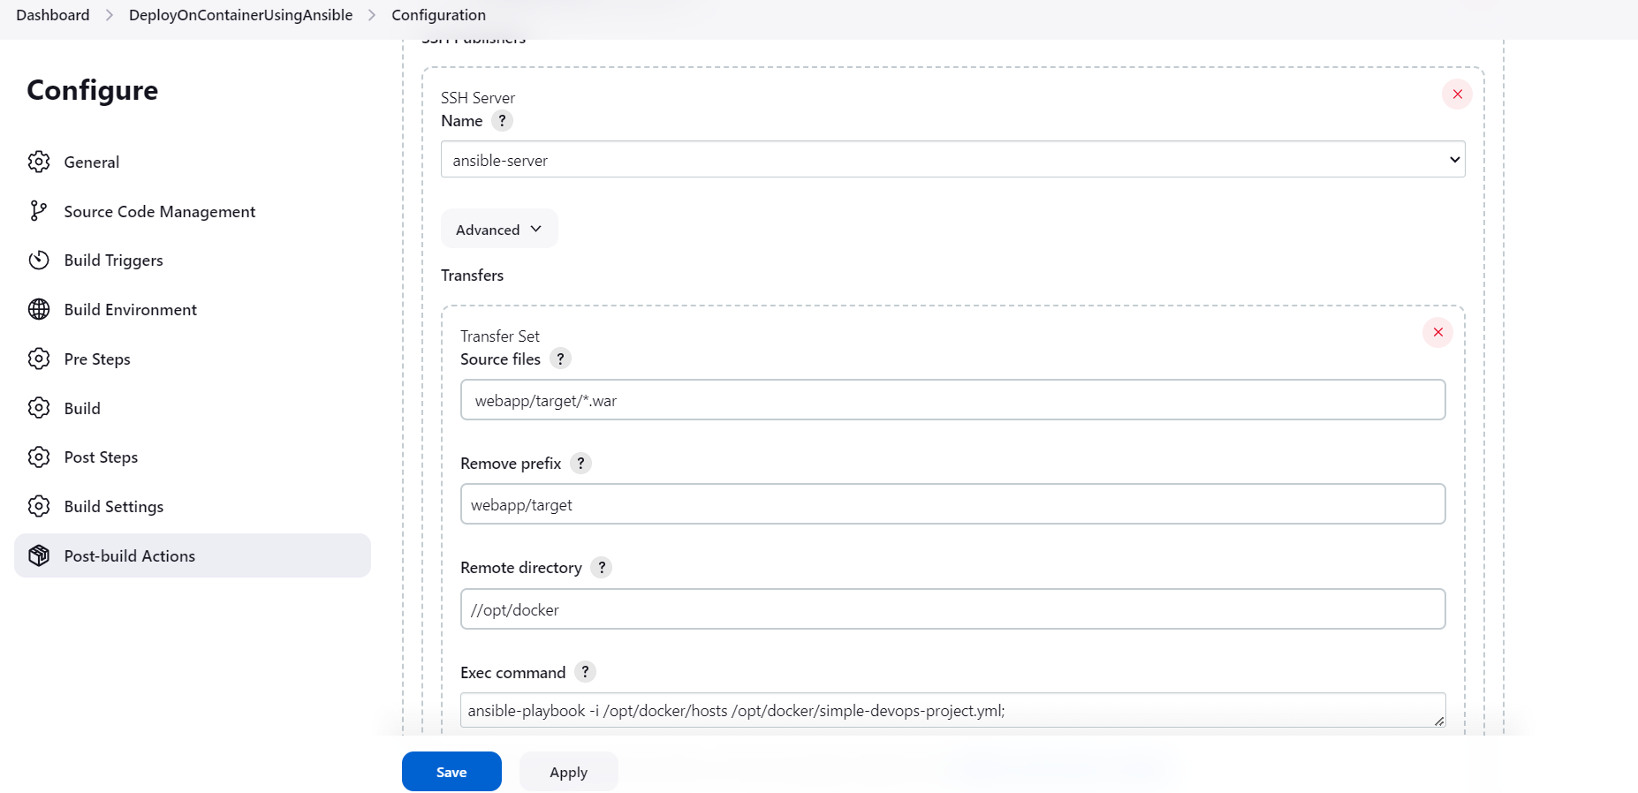

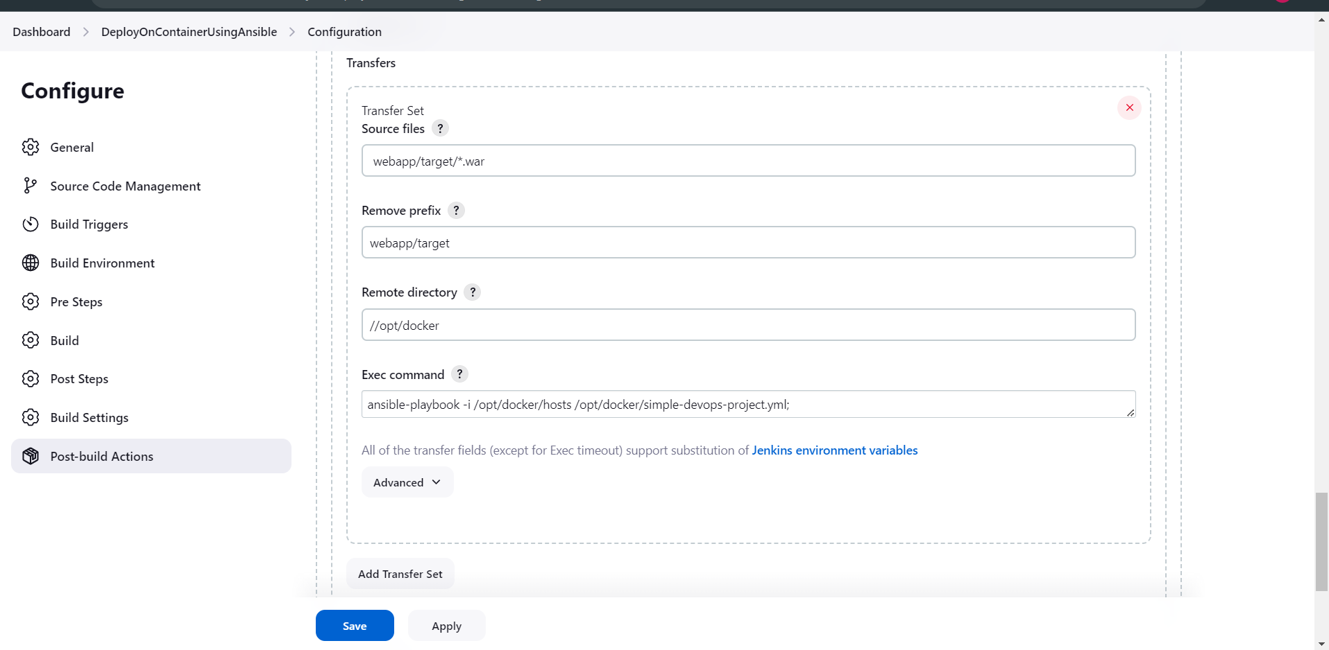

Now, check the console output

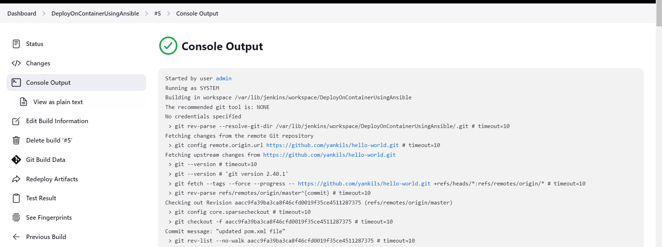

Now , you can see the changed file and the changes will also reflected automatically.

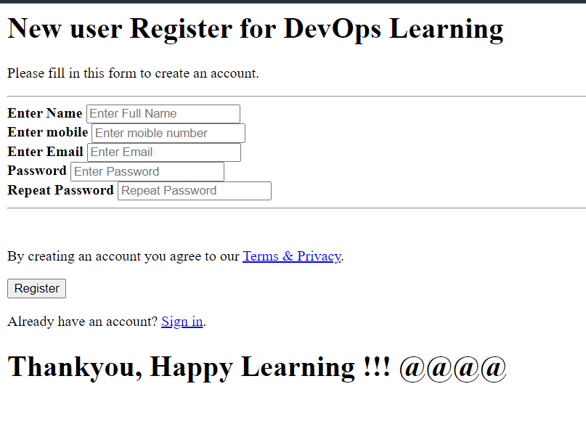

DockerHub Integration into Ansible

Go to the <https://hub.docker.com/login> and create one account . And go to the create repository and keep it as public but generally in real time all the project images are private repositories.

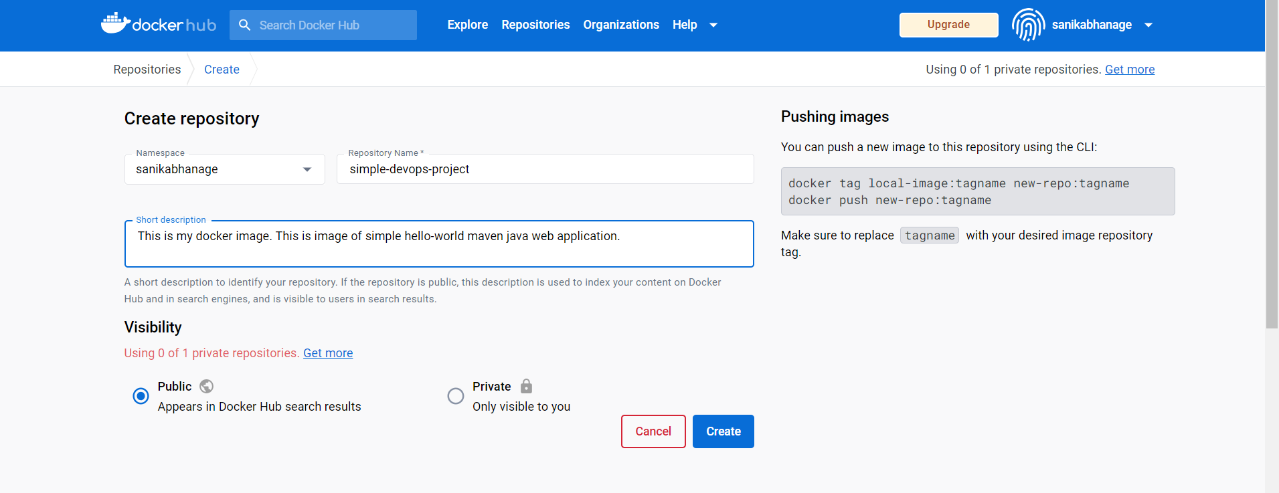

Goto the ansible-server you will see the project image

#docker images if you have not then rerun Jenkins job this will generate new image for you.

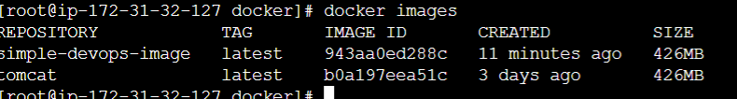

Now, copy the repository name sanikabhanage/simple-devops-project and using tag command rename the simple-devops-image for deployment on dockerhub.

#docker images

#docker tag simple-devops-image sanikabhanage/simple-devops-project

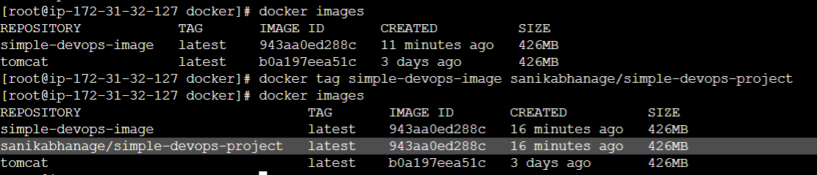

First login to the dockerhub using #docker login. Provide username and password. You will get login successfully message.

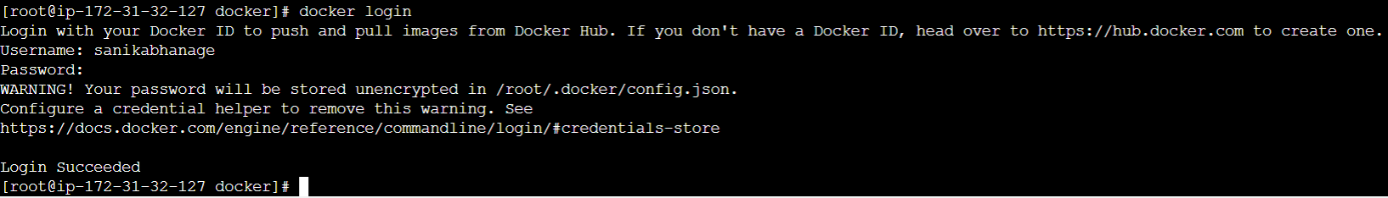

Now, push our new image to the docker hub #docker push sanikabhanage/simple-devops-project

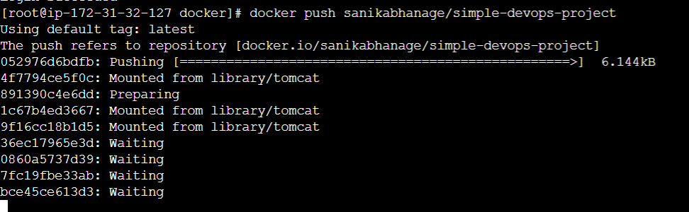

After refreshing the docker hub you will find your image

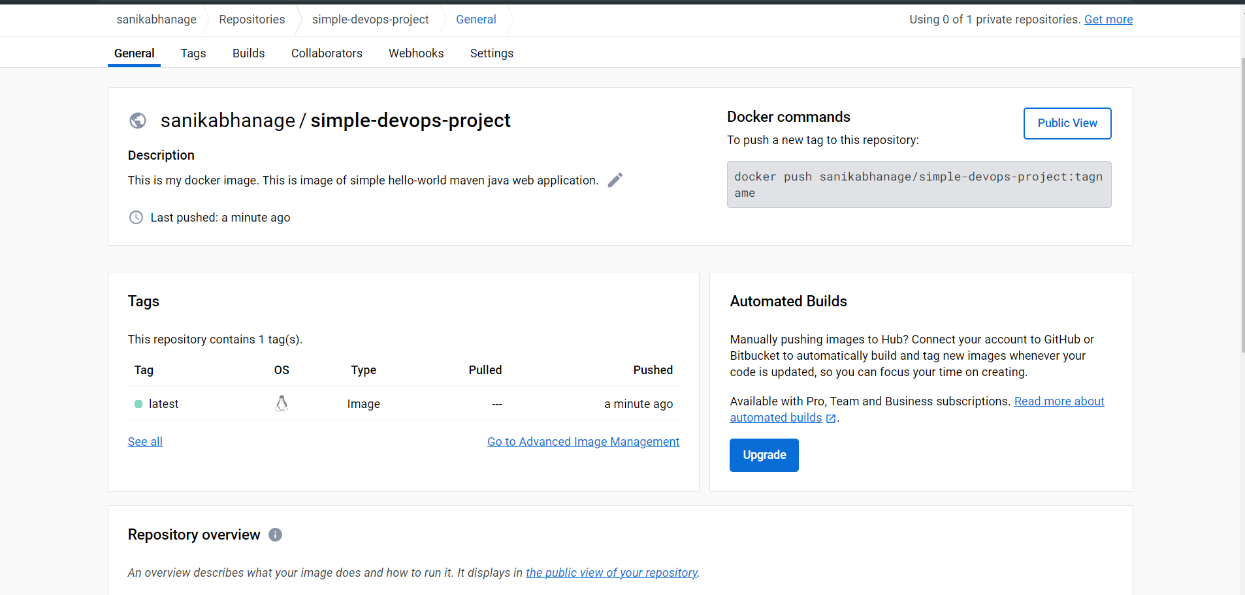

Now, to pull the docker image I have loginned as ansadmin and deleted my old docker images builded on project,

And pull from dockerhub my image

docker pull sanikabhanage/simple-devops-project

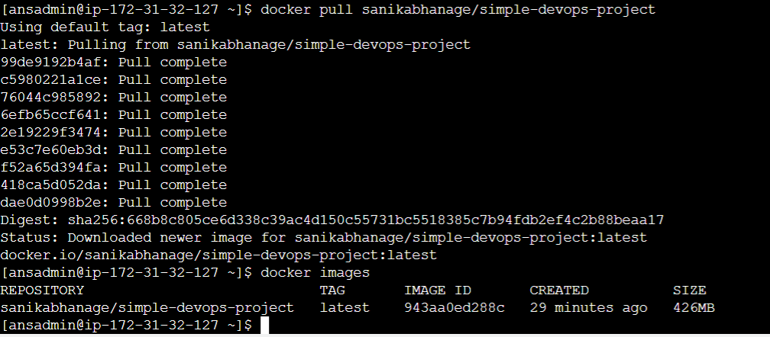

Create one yml file that will automate this task. Login to the ansadmin and create file named create-simple-devops-project.yml

---

- hosts: all

become: true

tasks:

- name: create docker image using war file

command: docker build -t simple-devops-image .

args:

chdir: /opt/docker

- name: create tag to the image

command: docker tag simple-devops-image sanikabhanage/simple-devops-project

- name: push image onto the dockerhub

command: docker push sanikabhanage/simple-devops-project

- name: remove the docker image from the ansible-server

command: docker rmi sanikabhanage/simple-devops-project

ignore_errors: yes

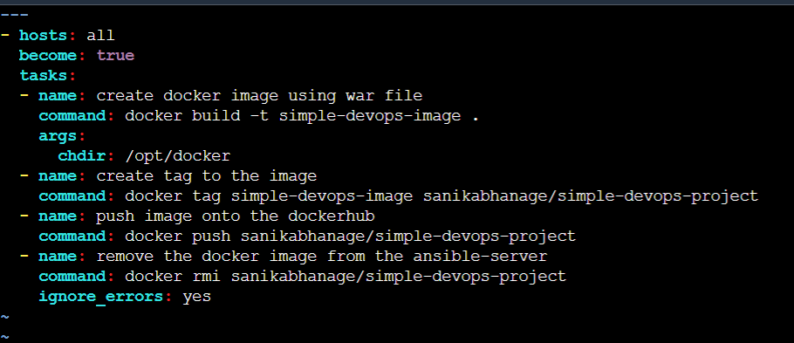

Now, run the ansible playbook, and this time create hosts file add localhost as content in it.

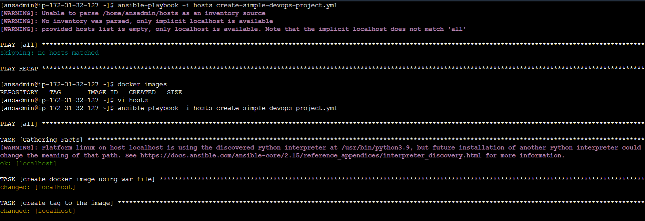

You can see our docker image created successfully.

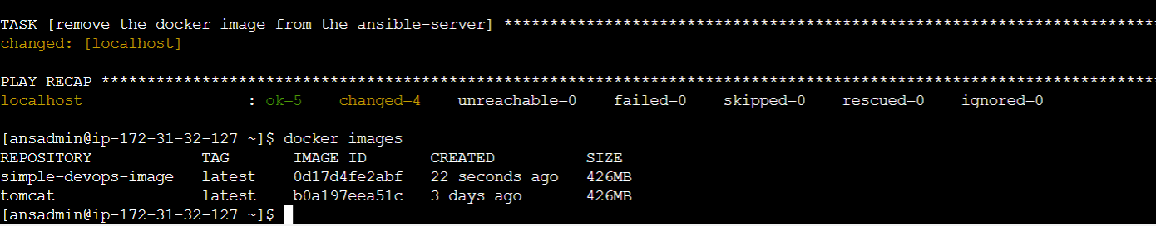

But, if there is any container running with that image then it will show error to delete the image hence we first check for any running container stopped that container and remove the container . Hence we have to edit that yml file.

---

- hosts: all

become: true

tasks:

- name: stop if we have old docker container

command: docker stop simple-devops-container

ignore_errors: yes

- name: remove stopped docker container

command: docker rm simple-devops-container

ignore_errors: yes

- name: remove current docker image

command: docker rmi sanikabhanage/simple-devops-project

ignore_errors: yes

- name: pull docker image from the dockerhub

command: docker pull sanikabhanage/simple-devops-project

- name: create the docker using image on the ansible-server

command: docker run -d --name simple-devops-container -p 8080:8080 sanikabhanage/simple-devops-project

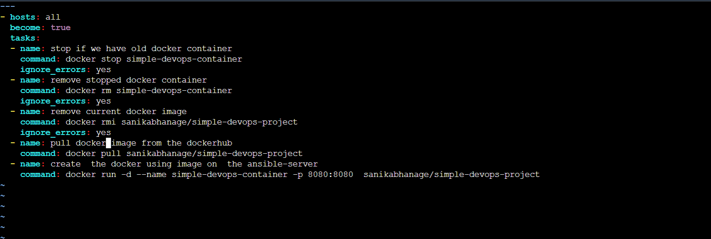

Now, run the playbook, created simple-devops-project.yml new file.

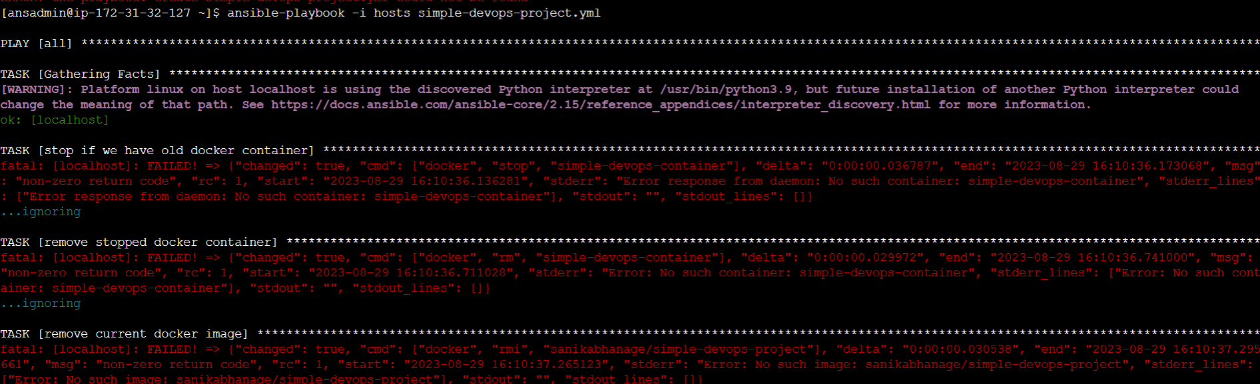

Docker images shows newly pulled image

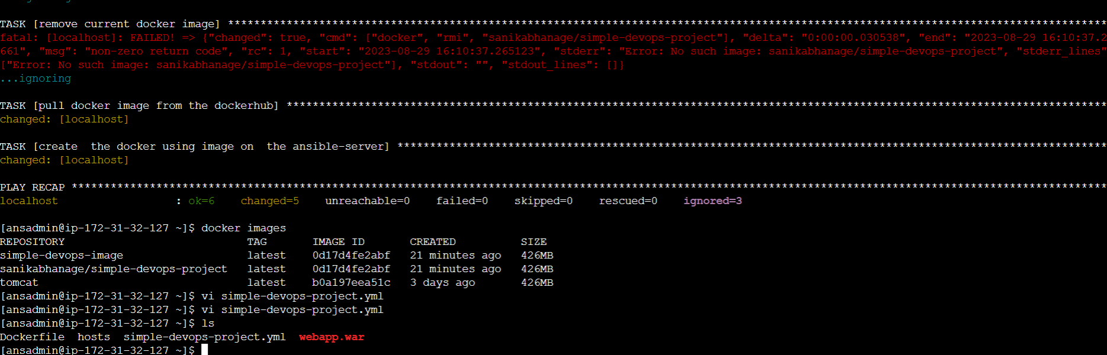

Now, edit the hosts file and add the private ip of the docker ec2 instance

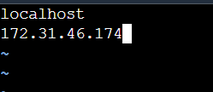

Now, limit the ansible playbook to only localhost using command

ansible-playbook -i hosts simple-devops-image.yml --limit localhost

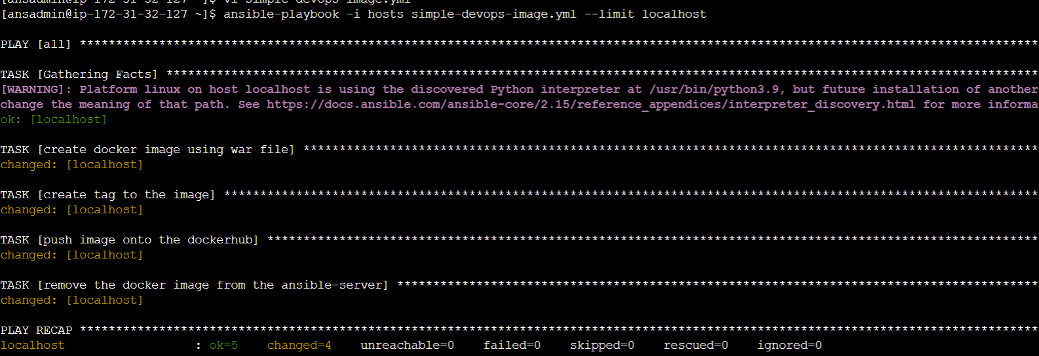

Now, we want to create the container using this image on the docker ec2 instance. For that, first check whether there is any running container on the target system and delete those image and its container.

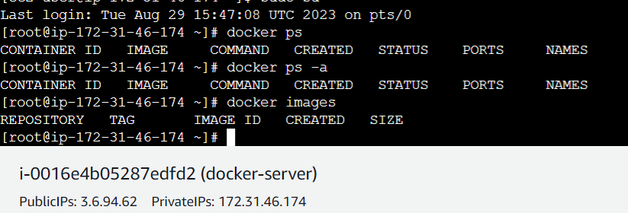

To run the playbook use # ansible-playbook -i /etc/ansible/hosts simple-devops-project.yml --limit 172.31.46.174

This is that ip address that we have mentioned in the hosts file of docker ec2 instance.

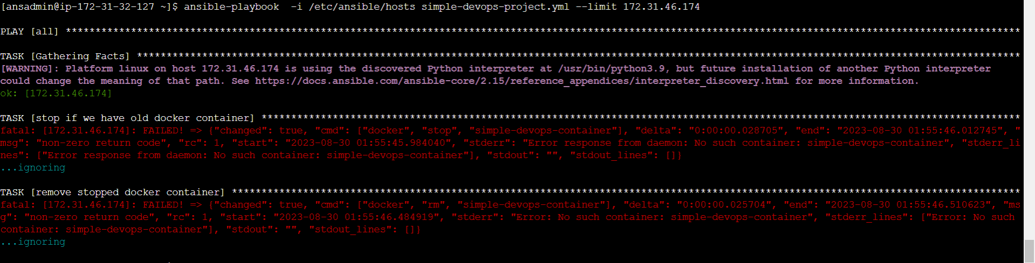

Now on docker ec2 instance check whether the docker container is running or not.



Goto the browser and check for container with docker ec2 instance public ip.

Now, using Jenkins run the job

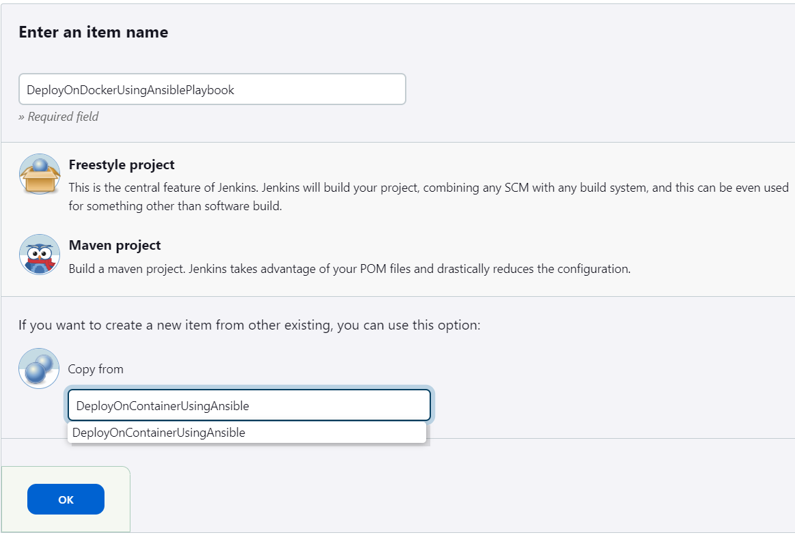

Description and github link is same. Now, add the build triggers as POLLSCM

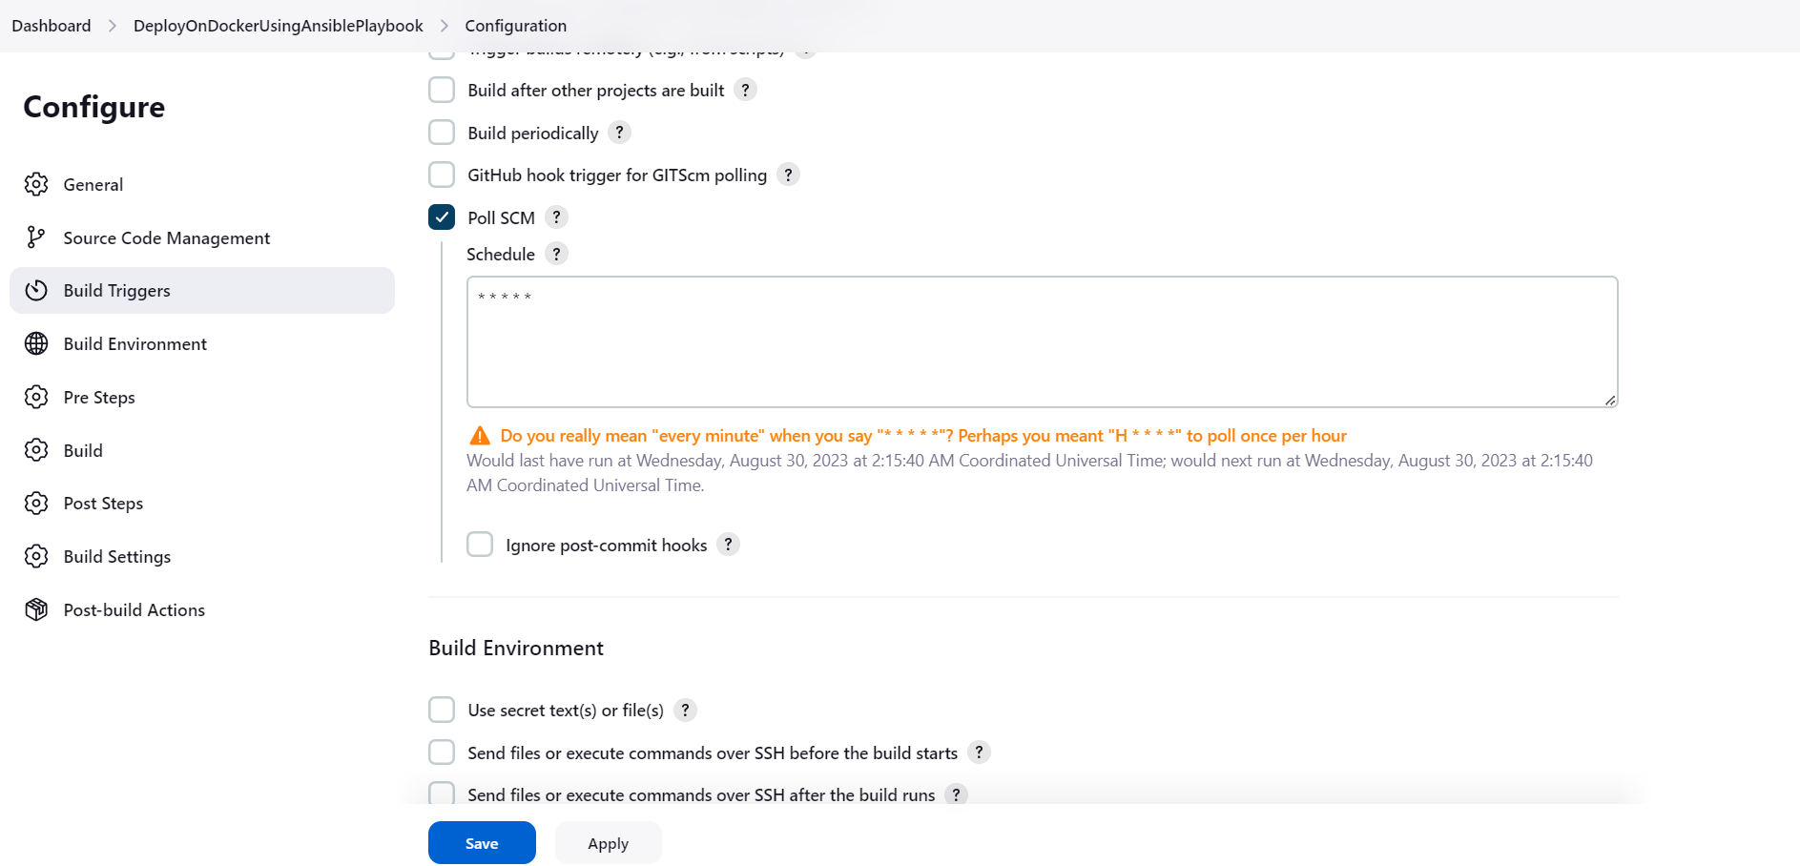

In the SSH-server add the docker exec command as

ansible-playbook -i /opt/docker/hosts /opt/docker/simple-devops-image.yml;

ansible-playbook -i /etc/ansible/hosts /opt/docker/simple-devops-project.yml --limit 172.31.46.174

Now, click on apply and save and build now.

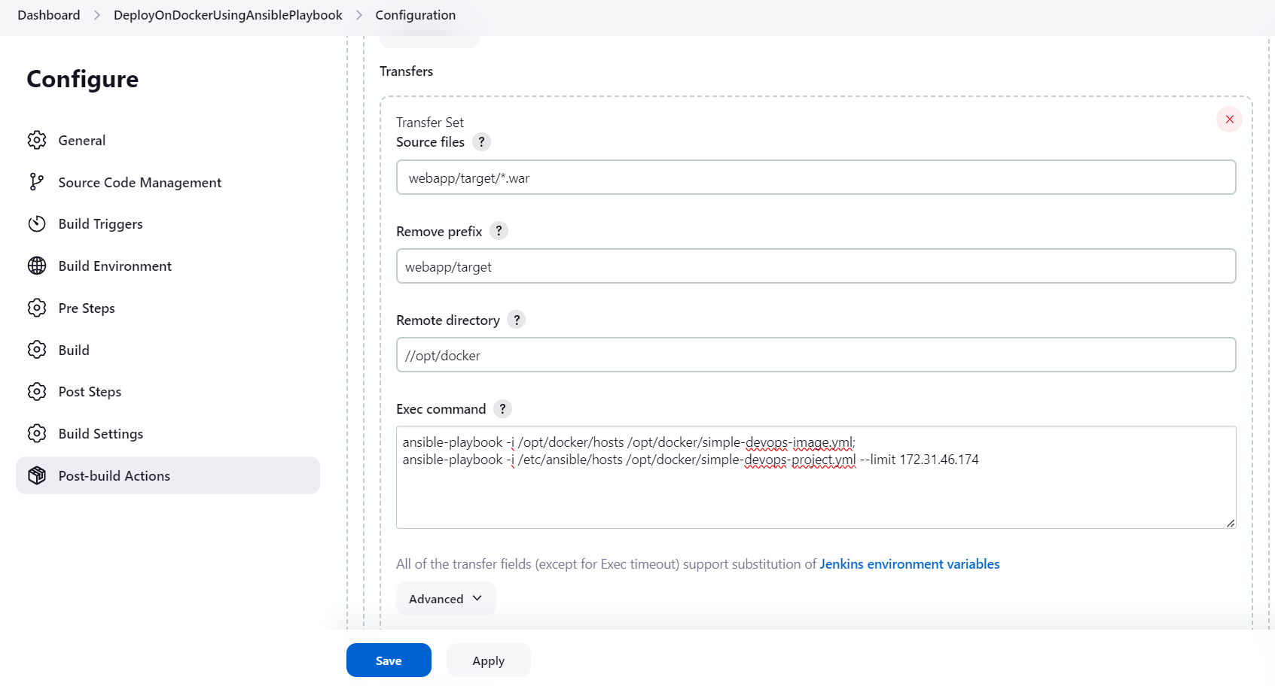

Now check in the browser

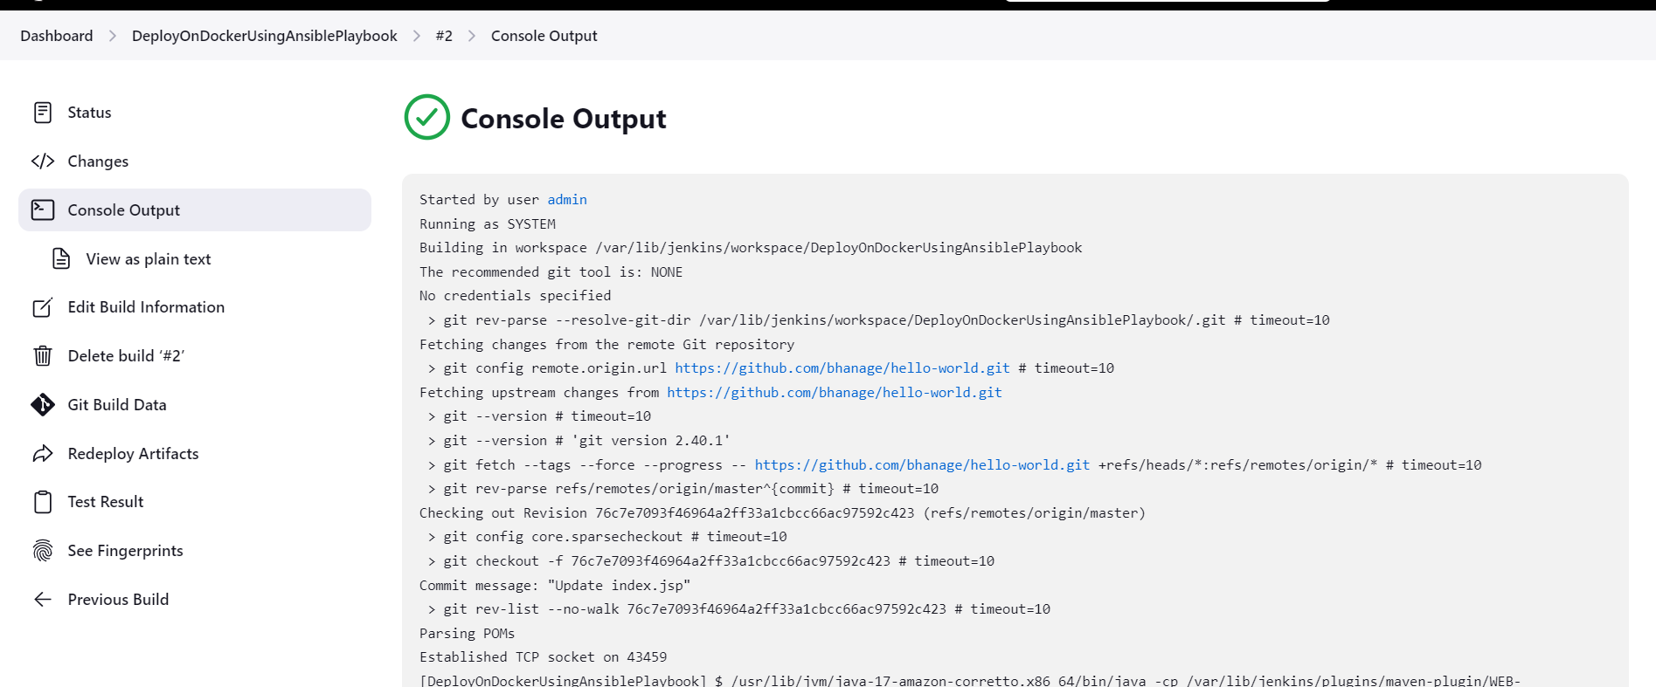

http://<public-ip-docker>:8080/webapp and also check dockerhub there is updatation in count of pull of image.

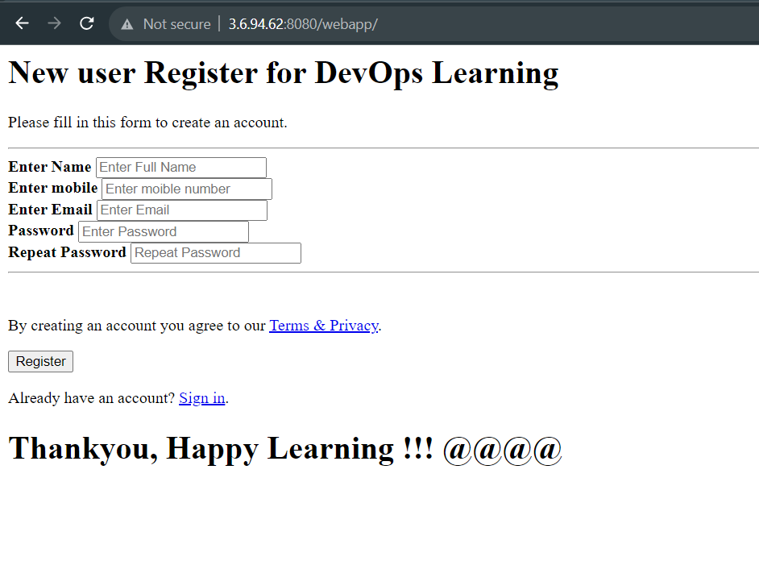

Now, modify the source code and push to the github repository and then check whether the commit will occur or not. And build the job again.

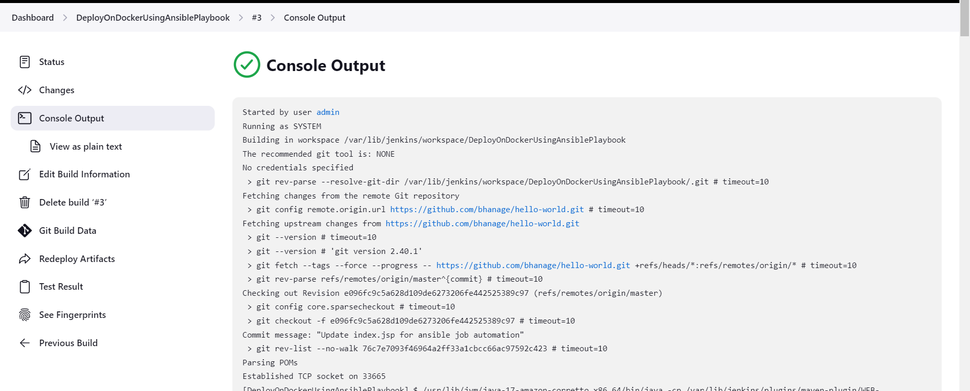

And now refresh the browser page and check whether updations are there or not. You can see that our changes are reflected.

